

Lab Manual

|  |  |  |
| --- | --- | --- |
| **Subject** | OPERATING SYSTEM | |
| **Submitted by** | Muhammad Khubaib | 23-st-017 |
| **Semester** | Spring 2023 (4th Semester) | |

## Department of Software Engineering Technology

##### Lab 1 :Introduction to Linux

**Objective:**

The objective of this lab is to familiarize students with the Linux environment, including its history, architecture, shell usage, and basic commands.

##### Basic Linux History and Architecture

* + Linux is an open-source operating system based on UNIX, developed by Linus Torvalds in 1991.
  + It follows a monolithic kernel architecture, meaning that the entire OS runs in kernel mode, providing direct hardware access.
  + The core components include:
    - **Kernel:** Manages hardware and system processes.
    - **Shell:** Interface between users and the kernel.
    - **File System:** Organizes data in a hierarchical structure.

##### 3. Linux File System Hierarchy

* The Linux file system is structured as follows:
  + / - Root directory (everything starts here)
  + /home - User files and directories
  + /etc - System configuration files
  + /var - Variable data (logs, caches)
  + /bin - Essential system binaries
  + /usr - User-installed software

1. 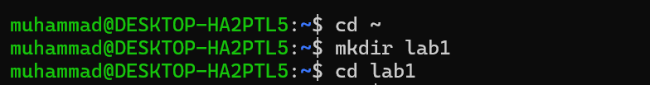**Navigate to the Home Directory and Create Lab1 Directory.**
2. **Check if the directory is created.**



1. **Inside Lab1,Create a text File Named test.txt.**



**Verify the file creation:**



1. **Display System Information.**



1. **Show Logged-in Users**

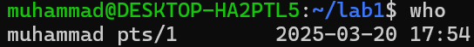

1. **Print the Current Date.**

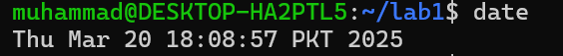

1. **Clean Up (Optional).**

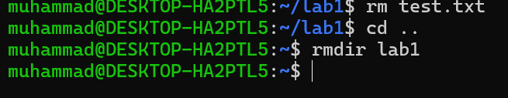

**GENERALIZED LAB RUBRICS**

|  |  |  |  |  |  |  |  |  |
| --- | --- | --- | --- | --- | --- | --- | --- | --- |
| **Domain** | **Component with Taxonomy** | **Above Expectatio n (4)** | **Meeting Expectatio n (3)** | **Approachin g Expectation**  **(2)** | **Below Expectatio n (1)** | **Used** | **Weight / 100**  **(Optional)** | **Scor e (1–**  **4)** |
| **Psychomotor** | **Building (**Hardware) | Is able to build a given setup neatly and timely using correct hardware components and / or can reorganize / adapt to new / special  requirements | Is able to assemble a given setup using correct hardware components after minor revisions | Is only able to copy a given setup using correct hardware components | Is not able to assemble a given setup using correct hardware components | ☐ |  |  |
| **Cognitive** | **Recording Measuremen ts** (Hardware  / Software) | Is able to record accurate measurements all the time | Is able to record accurate measurements most of the time | Is only able to record accurate measurements on some occasions | Is unable to record accurate measurements | ☐ |  |  |
| **Investigation**  (Software) | Is able to formulate  /develop theories in addition to evaluating  /concluding correctly about investigation parameters by assessing data | Is able to evaluate  /conclude correctly about investigation parameters by assessing data | Is partially able to evaluate  /conclude correctly about investigation parameters by assessing data | Is unable to comprehen d investigatio n  parameters | ☐ |  |  |
| **Design / Development of Solution** (Hardware / Software) | Is able to design / develop the solution of a given problem and add features to it | Is able to design / develop the solution of a given problem | Is able to partially design / develop the solution of a given problem | Is unable to partially design / develop the solution of a given problem | ☐ |  |  |
| **Software Usage** (Software) | Is adept in the use of software tool and can access advanced features | Is able to use the software tool effectively by accessing all the required  features | Is able to use the software tool but cannot access all the required features | Is unable to use the software tool | ☐ |  |  |
| **Programming Language** (Software) | Is able to efficiently complete a given task using advanced programming language constructs  / methods / commands and/or add features to the  original task | Is able to complete a given task using required programming language constructs / methods / commands | Is able to partially complete a given task | Is unable to partially complete a given task | ☐ |  |  |

**GENERALIZED LAB RUBRICS**

|  |  |  |  |  |  |  |  |  |
| --- | --- | --- | --- | --- | --- | --- | --- | --- |
| **Domain** | **Component with Taxonomy** | **Above Expectatio n (4)** | **Meeting**  **Expectati on (3)** | **Approachin g Expectation**  **(2)** | **Below Expectatio n (1)** | **Use d** | **Weight / 100**  **(Optional)** | **Scor e (1–**  **4)** |
| **Affective** | **Safety Instruction s (PLO6)** | Assesses and complies with all EHS instructions  while in lab | Assesses and complies with most EHS instructions while  in lab | Assesses and complies with some EHS instructions while in lab | Assesses and complies with few EHS instructions in lab | ☐ |  |  |
| **Profession al Ethics (PLO8)** | Exhibits exemplary professional ethics while writing lab reports and dealing with fellow students, lab staff and instructor all the time | Exhibits professional ethics while writing lab reports and dealing with fellow students, lab staff and instructor all the time | Makes an effort to exhibit professional ethics while writing lab reports and dealing with fellow students, lab staff and instructor all the time | Does not exhibit professional ethics while writing lab reports and dealing with fellow students, lab staff and instructor all the  time | ☐ |  |  |
| **Contributio n (PLO9)** | Consistently shows full preparation by completing all agreed tasks and provides additional resources for the group and work  quality is excellent | Consistently shows full preparation by completing all agreed tasks and work requires little or no revisions | Shows some preparation which is mostly at superficial level in completing a task and work requires much revisions and editing | Shows very little or no preparation in completing a task and work quality is poor | ☐ |  |  |
| **Attitude (PLO9)** | Internalized positive behavior and encourages and helps other  team members | Consistent positive behavior most of the time towards other  team members | Neither helpful nor damaging and shows disinterest in the performance of  others | Discouraging behavior towards other team members | ☐ |  |  |
| **Report Writing (PLO10)** | Report on all relevant sections related to the lab tasks is completed accurately, meeting the requirements, in prescribed time and with good language skills | Report on all relevant sections related to the lab tasks is completed but few deficiencies are present in terms of accuracy / meeting the requirements / prescribed time / good language  skills | Report on all relevant sections related to the lab tasks is completed but many deficiencies are present in terms of accuracy / meeting the requirements / prescribed time / good language  skills | Report on all relevant sections related to the lab tasks is not completed | ☐ |  |  |
| **Lab Task Manageme nt (PLO11)** | Manages tasks well within given timeframe | Manages tasks within given timeframe | Manages tasks in an extended timeframe | Does not manage tasks even in extended timeframes | ☐ |  |  |

##### Lab 2: File and Directory Management

**Objective:**

* Gain proficiency in basic file and directory operations.
* Understand file permissions and ownership.
* Learn to locate files using the find command.

##### Create a dedicated directory for this lab to avoid cluttering your system.

1. **File Manipulation Commands**
   * **Create a file:**
   * **Copy a file:**



* + **Rename/Move a file:**
    - **Delete a file:**



1. **Directory Commands**
   * **Create a directory:**

* **Move a file into the directory:**



* **Remove a directory and its contents:**



1. **File Permissions and Ownership**
   * 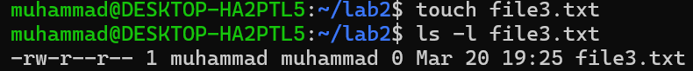**Check file permissions:**
   * **Change file permissions**

* **Give the owner execute permission:**



* **Remove read permission for the group:**
* **Change file ownership:**

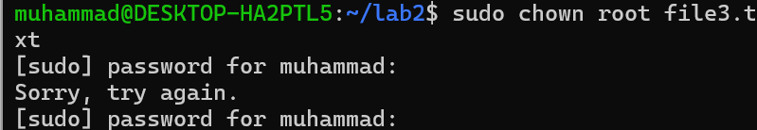

1. **Using find to locate file.**
   * **Create test files:**

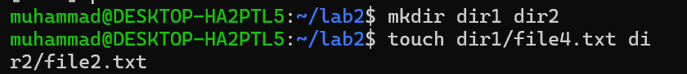

* **Find files by name:**
* 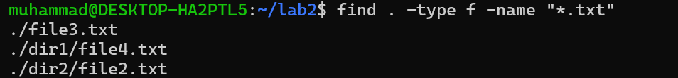**Find files by type:**
* **Find files by modification time:**

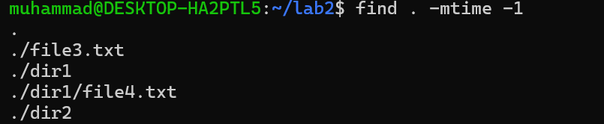

1. 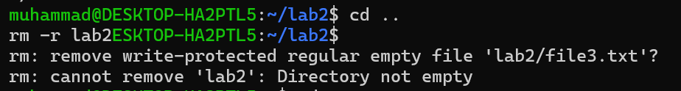**Cleanup:**

m

**GENERALIZED LAB RUBRICS**

|  |  |  |  |  |  |  |  |  |
| --- | --- | --- | --- | --- | --- | --- | --- | --- |
| **Domain** | **Component with Taxonomy** | **Above Expectatio n (4)** | **Meeting Expectatio n (3)** | **Approachin g Expectation**  **(2)** | **Below Expectatio n (1)** | **Used** | **Weight / 100**  **(Optional)** | **Scor e (1–**  **4)** |
| **Psychomotor** | **Building (**Hardware) | Is able to build a given setup neatly and timely using correct hardware components and / or can reorganize / adapt to new / special  requirements | Is able to assemble a given setup using correct hardware components after minor revisions | Is only able to copy a given setup using correct hardware components | Is not able to assemble a given setup using correct hardware components | ☐ |  |  |
| **Cognitive** | **Recording Measuremen ts** (Hardware  / Software) | Is able to record accurate measurements all the time | Is able to record accurate measurements most of the time | Is only able to record accurate measurements on some occasions | Is unable to record accurate measurements | ☐ |  |  |
| **Investigation**  (Software) | Is able to formulate  /develop theories in addition to evaluating  /concluding correctly about investigation parameters by assessing data | Is able to evaluate  /conclude correctly about investigation parameters by assessing data | Is partially able to evaluate  /conclude correctly about investigation parameters by assessing data | Is unable to comprehen d investigatio n  parameters | ☐ |  |  |
| **Design / Development of Solution** (Hardware / Software) | Is able to design / develop the solution of a given problem and add features to it | Is able to design / develop the solution of a given problem | Is able to partially design / develop the solution of a given problem | Is unable to partially design / develop the solution of a given problem | ☐ |  |  |
| **Software Usage** (Software) | Is adept in the use of software tool and can access advanced features | Is able to use the software tool effectively by accessing all the required  features | Is able to use the software tool but cannot access all the required features | Is unable to use the software tool | ☐ |  |  |
| **Programming Language** (Software) | Is able to efficiently complete a given task using advanced programming language constructs  / methods / commands and/or add features to the  original task | Is able to complete a given task using required programming language constructs / methods / commands | Is able to partially complete a given task | Is unable to partially complete a given task | ☐ |  |  |

**GENERALIZED LAB RUBRICS**

|  |  |  |  |  |  |  |  |  |
| --- | --- | --- | --- | --- | --- | --- | --- | --- |
| **Domain** | **Component with Taxonomy** | **Above Expectatio n (4)** | **Meeting**  **Expectati on (3)** | **Approachin g Expectation**  **(2)** | **Below Expectatio n (1)** | **Use d** | **Weight / 100**  **(Optional)** | **Scor e (1–**  **4)** |
| **Affective** | **Safety Instruction s (PLO6)** | Assesses and complies with all EHS instructions  while in lab | Assesses and complies with most EHS instructions while  in lab | Assesses and complies with some EHS instructions while in lab | Assesses and complies with few EHS instructions in lab | ☐ |  |  |
| **Profession al Ethics (PLO8)** | Exhibits exemplary professional ethics while writing lab reports and dealing with fellow students, lab staff and instructor all the time | Exhibits professional ethics while writing lab reports and dealing with fellow students, lab staff and instructor all the time | Makes an effort to exhibit professional ethics while writing lab reports and dealing with fellow students, lab staff and instructor all the time | Does not exhibit professional ethics while writing lab reports and dealing with fellow students, lab staff and instructor all the  time | ☐ |  |  |
| **Contributio n (PLO9)** | Consistently shows full preparation by completing all agreed tasks and provides additional resources for the group and work  quality is excellent | Consistently shows full preparation by completing all agreed tasks and work requires little or no revisions | Shows some preparation which is mostly at superficial level in completing a task and work requires much revisions and editing | Shows very little or no preparation in completing a task and work quality is poor | ☐ |  |  |
| **Attitude (PLO9)** | Internalized positive behavior and encourages and helps other  team members | Consistent positive behavior most of the time towards other  team members | Neither helpful nor damaging and shows disinterest in the performance of  others | Discouraging behavior towards other team members | ☐ |  |  |
| **Report Writing (PLO10)** | Report on all relevant sections related to the lab tasks is completed accurately, meeting the requirements, in prescribed time and with good language skills | Report on all relevant sections related to the lab tasks is completed but few deficiencies are present in terms of accuracy / meeting the requirements / prescribed time / good language  skills | Report on all relevant sections related to the lab tasks is completed but many deficiencies are present in terms of accuracy / meeting the requirements / prescribed time / good language  skills | Report on all relevant sections related to the lab tasks is not completed | ☐ |  |  |
| **Lab Task Manageme nt (PLO11)** | Manages tasks well within given timeframe | Manages tasks within given timeframe | Manages tasks in an extended timeframe | Does not manage tasks even in extended timeframes | ☐ |  |  |

##### Lab 3: Working with Text Files in Linux Objective:

Learn how to manipulate and process text files using Linux commands.

##### Create a Directory for Lab 3

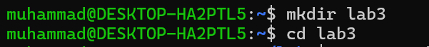**Before starting, create a dedicated directory:**

##### Create and View Files

* + **Create a Sample Text File:**
  + View File Contents:

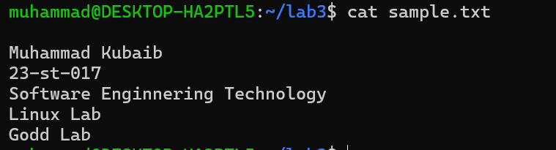

* + 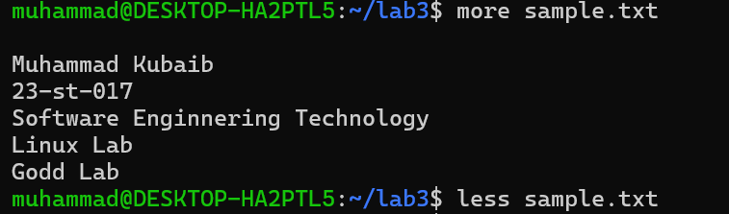**View file with pagination:**
  + **View the first 2 lines and last 3 lines:**

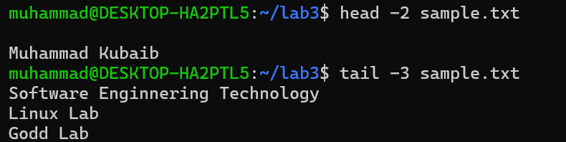

##### Edit Files

* + **Use nano or vi to edit:**

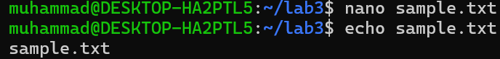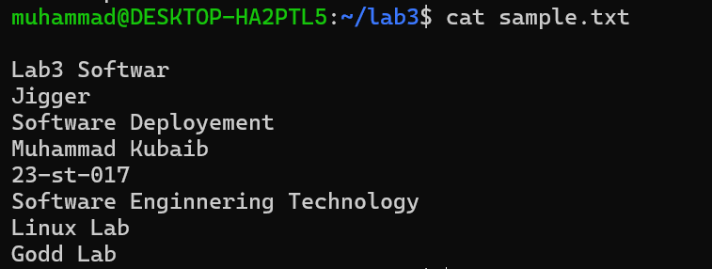

##### Search for Text Patterns

* + **Find a Word in a File**
  + **Find a Word and Show Line Numbers**



* + **Case-Insensitive Search**
  + **Search for Lines That Do Not Contain a Word.**

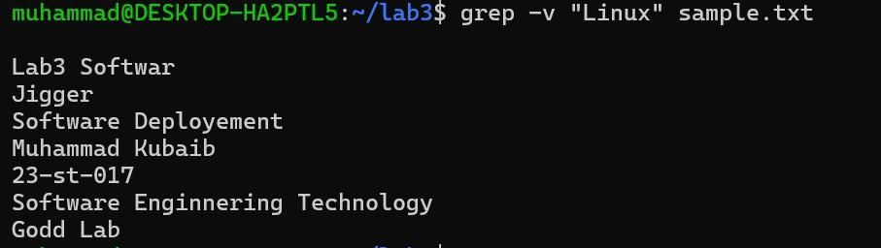

##### Combine and Split Files

* + **Concatenate (Join) Multiple Files**
* **Create another file:**
* **Combine both files into a new file:**



* 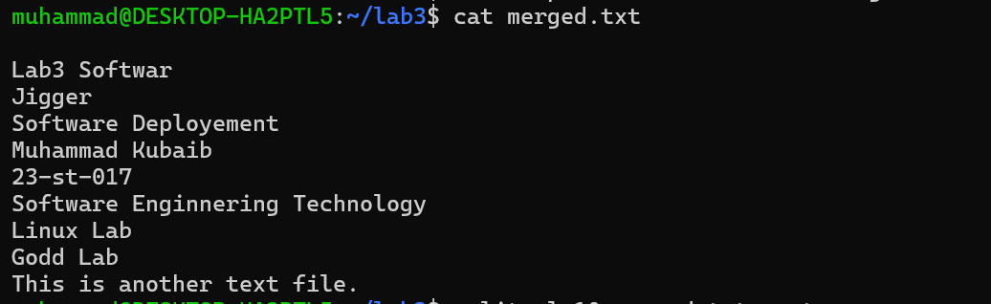**View the new file:**
  + **Split a Large File**
* **To split a large file into smaller parts:**

##### Delete a File or Directory

* + **To remove a file:**
  + **To remove a directory and all its contents:**

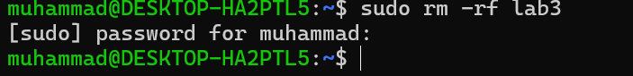

**GENERALIZED LAB RUBRICS**

|  |  |  |  |  |  |  |  |  |
| --- | --- | --- | --- | --- | --- | --- | --- | --- |
| **Domain** | **Component with Taxonomy** | **Above Expectatio n (4)** | **Meeting Expectatio n (3)** | **Approachin g Expectation**  **(2)** | **Below Expectatio n (1)** | **Used** | **Weight / 100**  **(Optional)** | **Scor e (1–**  **4)** |
| **Psychomotor** | **Building (**Hardware) | Is able to build a given setup neatly and timely using correct hardware components and / or can reorganize / adapt to new / special  requirements | Is able to assemble a given setup using correct hardware components after minor revisions | Is only able to copy a given setup using correct hardware components | Is not able to assemble a given setup using correct hardware components | ☐ |  |  |
| **Cognitive** | **Recording Measuremen ts** (Hardware  / Software) | Is able to record accurate measurements all the time | Is able to record accurate measurements most of the time | Is only able to record accurate measurements on some occasions | Is unable to record accurate measurements | ☐ |  |  |
| **Investigation**  (Software) | Is able to formulate  /develop theories in addition to evaluating  /concluding correctly about investigation parameters by assessing data | Is able to evaluate  /conclude correctly about investigation parameters by assessing data | Is partially able to evaluate  /conclude correctly about investigation parameters by assessing data | Is unable to comprehen d investigatio n  parameters | ☐ |  |  |
| **Design / Development of Solution** (Hardware / Software) | Is able to design / develop the solution of a given problem and add features to it | Is able to design / develop the solution of a given problem | Is able to partially design / develop the solution of a given problem | Is unable to partially design / develop the solution of a given problem | ☐ |  |  |
| **Software Usage** (Software) | Is adept in the use of software tool and can access advanced features | Is able to use the software tool effectively by accessing all the required  features | Is able to use the software tool but cannot access all the required features | Is unable to use the software tool | ☐ |  |  |
| **Programming Language** (Software) | Is able to efficiently complete a given task using advanced programming language constructs  / methods / commands and/or add features to the  original task | Is able to complete a given task using required programming language constructs / methods / commands | Is able to partially complete a given task | Is unable to partially complete a given task | ☐ |  |  |

**GENERALIZED LAB RUBRICS**

|  |  |  |  |  |  |  |  |  |
| --- | --- | --- | --- | --- | --- | --- | --- | --- |
| **Domain** | **Component with Taxonomy** | **Above Expectatio n (4)** | **Meeting**  **Expectati on (3)** | **Approachin g Expectation**  **(2)** | **Below Expectatio n (1)** | **Use d** | **Weight / 100**  **(Optional)** | **Scor e (1–**  **4)** |
| **Affective** | **Safety Instruction s (PLO6)** | Assesses and complies with all EHS instructions  while in lab | Assesses and complies with most EHS instructions while  in lab | Assesses and complies with some EHS instructions while in lab | Assesses and complies with few EHS instructions in lab | ☐ |  |  |
| **Profession al Ethics (PLO8)** | Exhibits exemplary professional ethics while writing lab reports and dealing with fellow students, lab staff and instructor all the time | Exhibits professional ethics while writing lab reports and dealing with fellow students, lab staff and instructor all the time | Makes an effort to exhibit professional ethics while writing lab reports and dealing with fellow students, lab staff and instructor all the time | Does not exhibit professional ethics while writing lab reports and dealing with fellow students, lab staff and instructor all the  time | ☐ |  |  |
| **Contributio n (PLO9)** | Consistently shows full preparation by completing all agreed tasks and provides additional resources for the group and work  quality is excellent | Consistently shows full preparation by completing all agreed tasks and work requires little or no revisions | Shows some preparation which is mostly at superficial level in completing a task and work requires much revisions and editing | Shows very little or no preparation in completing a task and work quality is poor | ☐ |  |  |
| **Attitude (PLO9)** | Internalized positive behavior and encourages and helps other  team members | Consistent positive behavior most of the time towards other  team members | Neither helpful nor damaging and shows disinterest in the performance of  others | Discouraging behavior towards other team members | ☐ |  |  |
| **Report Writing (PLO10)** | Report on all relevant sections related to the lab tasks is completed accurately, meeting the requirements, in prescribed time and with good language skills | Report on all relevant sections related to the lab tasks is completed but few deficiencies are present in terms of accuracy / meeting the requirements / prescribed time / good language  skills | Report on all relevant sections related to the lab tasks is completed but many deficiencies are present in terms of accuracy / meeting the requirements / prescribed time / good language  skills | Report on all relevant sections related to the lab tasks is not completed | ☐ |  |  |
| **Lab Task Manageme nt (PLO11)** | Manages tasks well within given timeframe | Manages tasks within given timeframe | Manages tasks in an extended timeframe | Does not manage tasks even in extended timeframes | ☐ |  |  |

##### Lab 4: Managing Users and Groups in Linux

**Objective:**

Learn to create and manage users, assign groups, and control file permissions in Linux.

1. **Create a New User**

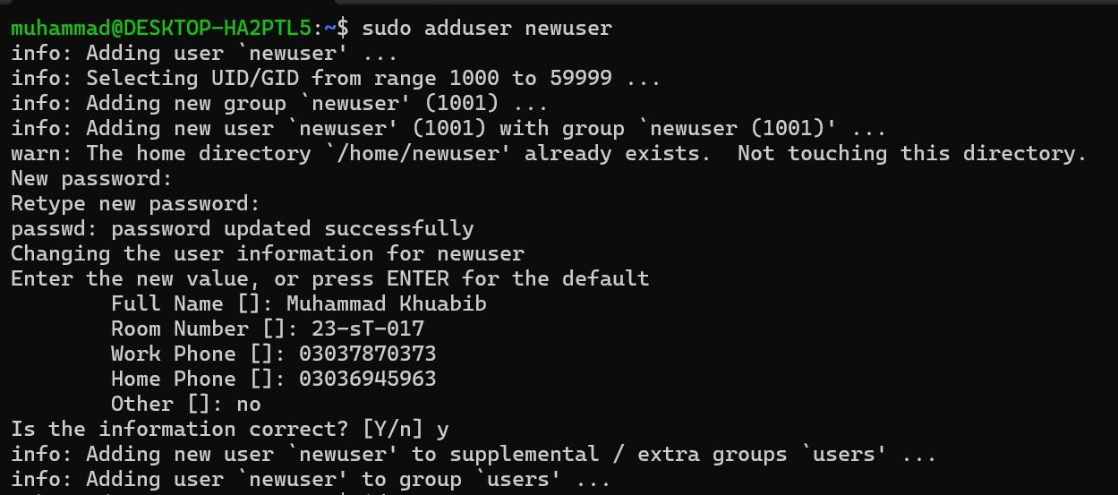

* + **Verify the User Creation**



1. **Assign the User to a Group**
   * **Create a New Group and add user to group and verify Membership.**

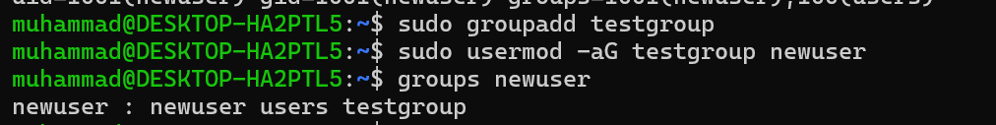

##### Switch to the New User

* + **Log in as the newly created user and check username(newuser):**

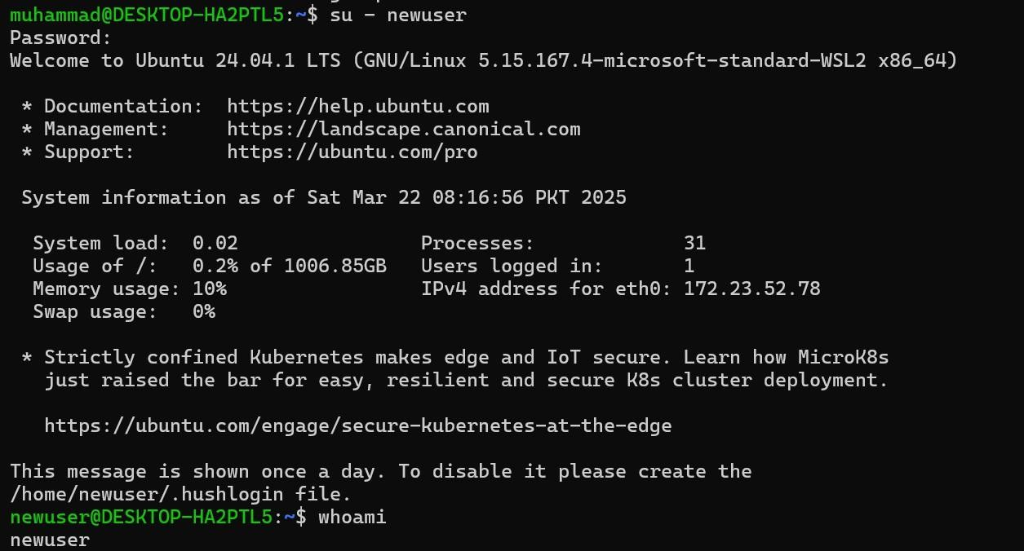

##### Test File Access with Different Permissions

* + **Create a Test File**



* + **Check the file's permissions:**



* + **Change File Permissions**



* + **Try modifying the file:**



* + **Grant Write Access to the Group**



1. **Delete the User and Group**
   * **Remove the User and Group and home directories:**

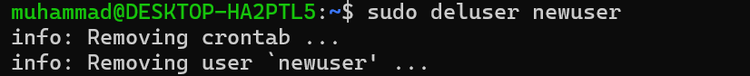

* + **Remove the Group and Home Directory of the user:**

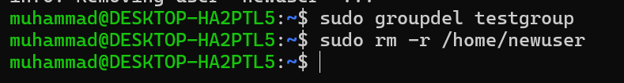

**GENERALIZED LAB RUBRICS**

|  |  |  |  |  |  |  |  |  |
| --- | --- | --- | --- | --- | --- | --- | --- | --- |
| **Domain** | **Component with Taxonomy** | **Above Expectatio n (4)** | **Meeting Expectatio n (3)** | **Approachin g Expectation**  **(2)** | **Below Expectatio n (1)** | **Used** | **Weight / 100**  **(Optional)** | **Scor e (1–**  **4)** |
| **Psychomotor** | **Building (**Hardware) | Is able to build a given setup neatly and timely using correct hardware components and / or can reorganize / adapt to new / special  requirements | Is able to assemble a given setup using correct hardware components after minor revisions | Is only able to copy a given setup using correct hardware components | Is not able to assemble a given setup using correct hardware components | ☐ |  |  |
| **Cognitive** | **Recording Measuremen ts** (Hardware  / Software) | Is able to record accurate measurements all the time | Is able to record accurate measurements most of the time | Is only able to record accurate measurements on some occasions | Is unable to record accurate measurements | ☐ |  |  |
| **Investigation**  (Software) | Is able to formulate  /develop theories in addition to evaluating  /concluding correctly about investigation parameters by assessing data | Is able to evaluate  /conclude correctly about investigation parameters by assessing data | Is partially able to evaluate  /conclude correctly about investigation parameters by assessing data | Is unable to comprehen d investigatio n  parameters | ☐ |  |  |
| **Design / Development of Solution** (Hardware / Software) | Is able to design / develop the solution of a given problem and add features to it | Is able to design / develop the solution of a given problem | Is able to partially design / develop the solution of a given problem | Is unable to partially design / develop the solution of a given problem | ☐ |  |  |
| **Software Usage** (Software) | Is adept in the use of software tool and can access advanced features | Is able to use the software tool effectively by accessing all the required  features | Is able to use the software tool but cannot access all the required features | Is unable to use the software tool | ☐ |  |  |
| **Programming Language** (Software) | Is able to efficiently complete a given task using advanced programming language constructs  / methods / commands and/or add features to the  original task | Is able to complete a given task using required programming language constructs / methods / commands | Is able to partially complete a given task | Is unable to partially complete a given task | ☐ |  |  |

**GENERALIZED LAB RUBRICS**

|  |  |  |  |  |  |  |  |  |
| --- | --- | --- | --- | --- | --- | --- | --- | --- |
| **Domain** | **Component with Taxonomy** | **Above Expectatio n (4)** | **Meeting**  **Expectati on (3)** | **Approachin g Expectation**  **(2)** | **Below Expectatio n (1)** | **Use d** | **Weight / 100**  **(Optional)** | **Scor e (1–**  **4)** |
| **Affective** | **Safety Instruction s (PLO6)** | Assesses and complies with all EHS instructions  while in lab | Assesses and complies with most EHS instructions while  in lab | Assesses and complies with some EHS instructions while in lab | Assesses and complies with few EHS instructions in lab | ☐ |  |  |
| **Profession al Ethics (PLO8)** | Exhibits exemplary professional ethics while writing lab reports and dealing with fellow students, lab staff and instructor all the time | Exhibits professional ethics while writing lab reports and dealing with fellow students, lab staff and instructor all the time | Makes an effort to exhibit professional ethics while writing lab reports and dealing with fellow students, lab staff and instructor all the time | Does not exhibit professional ethics while writing lab reports and dealing with fellow students, lab staff and instructor all the  time | ☐ |  |  |
| **Contributio n (PLO9)** | Consistently shows full preparation by completing all agreed tasks and provides additional resources for the group and work  quality is excellent | Consistently shows full preparation by completing all agreed tasks and work requires little or no revisions | Shows some preparation which is mostly at superficial level in completing a task and work requires much revisions and editing | Shows very little or no preparation in completing a task and work quality is poor | ☐ |  |  |
| **Attitude (PLO9)** | Internalized positive behavior and encourages and helps other  team members | Consistent positive behavior most of the time towards other  team members | Neither helpful nor damaging and shows disinterest in the performance of  others | Discouraging behavior towards other team members | ☐ |  |  |
| **Report Writing (PLO10)** | Report on all relevant sections related to the lab tasks is completed accurately, meeting the requirements, in prescribed time and with good language skills | Report on all relevant sections related to the lab tasks is completed but few deficiencies are present in terms of accuracy / meeting the requirements / prescribed time / good language  skills | Report on all relevant sections related to the lab tasks is completed but many deficiencies are present in terms of accuracy / meeting the requirements / prescribed time / good language  skills | Report on all relevant sections related to the lab tasks is not completed | ☐ |  |  |
| **Lab Task Manageme nt (PLO11)** | Manages tasks well within given timeframe | Manages tasks within given timeframe | Manages tasks in an extended timeframe | Does not manage tasks even in extended timeframes | ☐ |  |  |

##### Lab 5: Process Management in Linux

**Objective:**

Work with processes and understand system resources.

##### View Running Processes

* 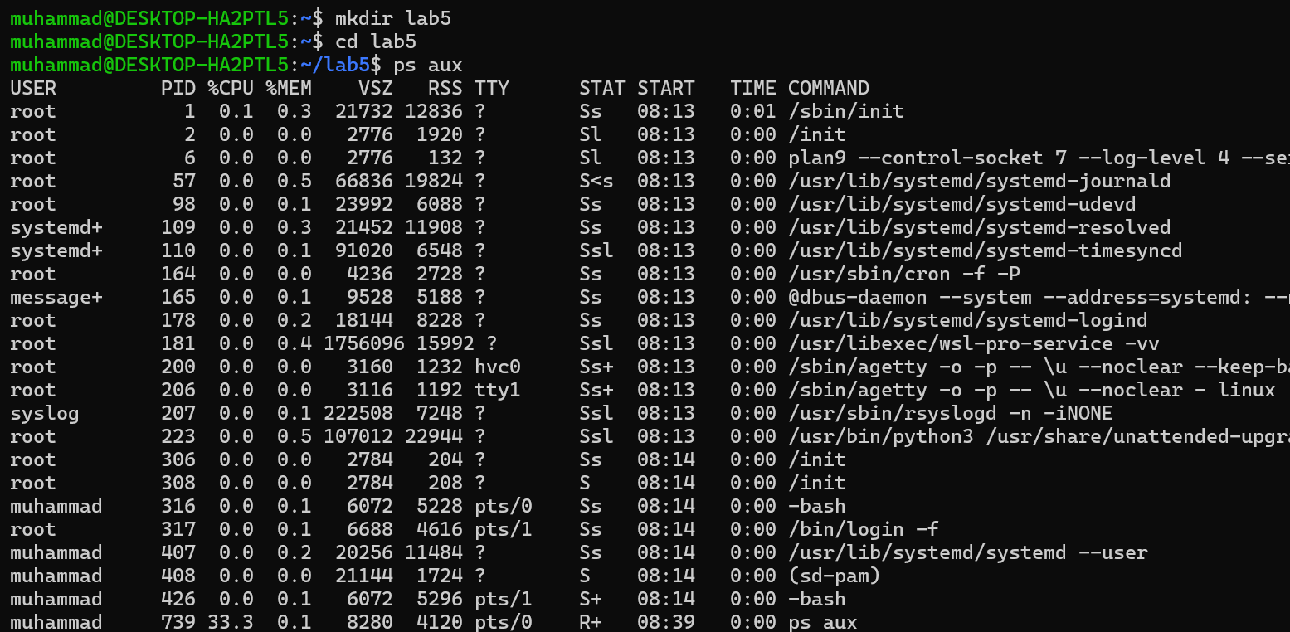**List active processes:**
* 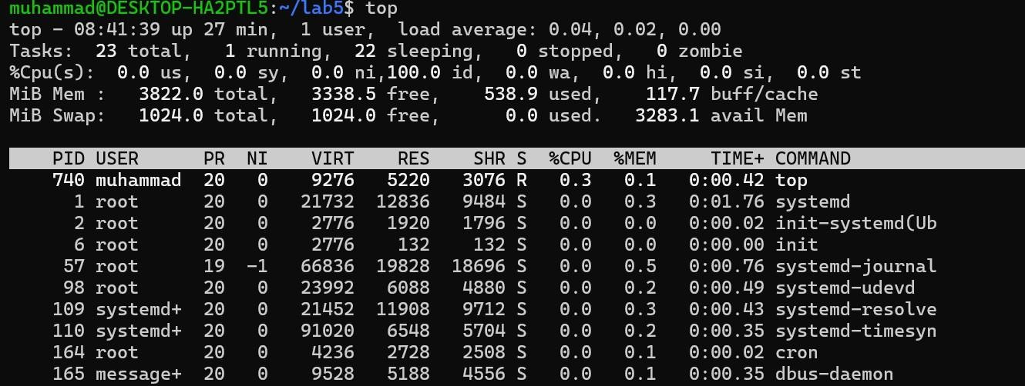**Display real-time process monitoring:**
* **Use an interactive process viewer (optional, if installed):**

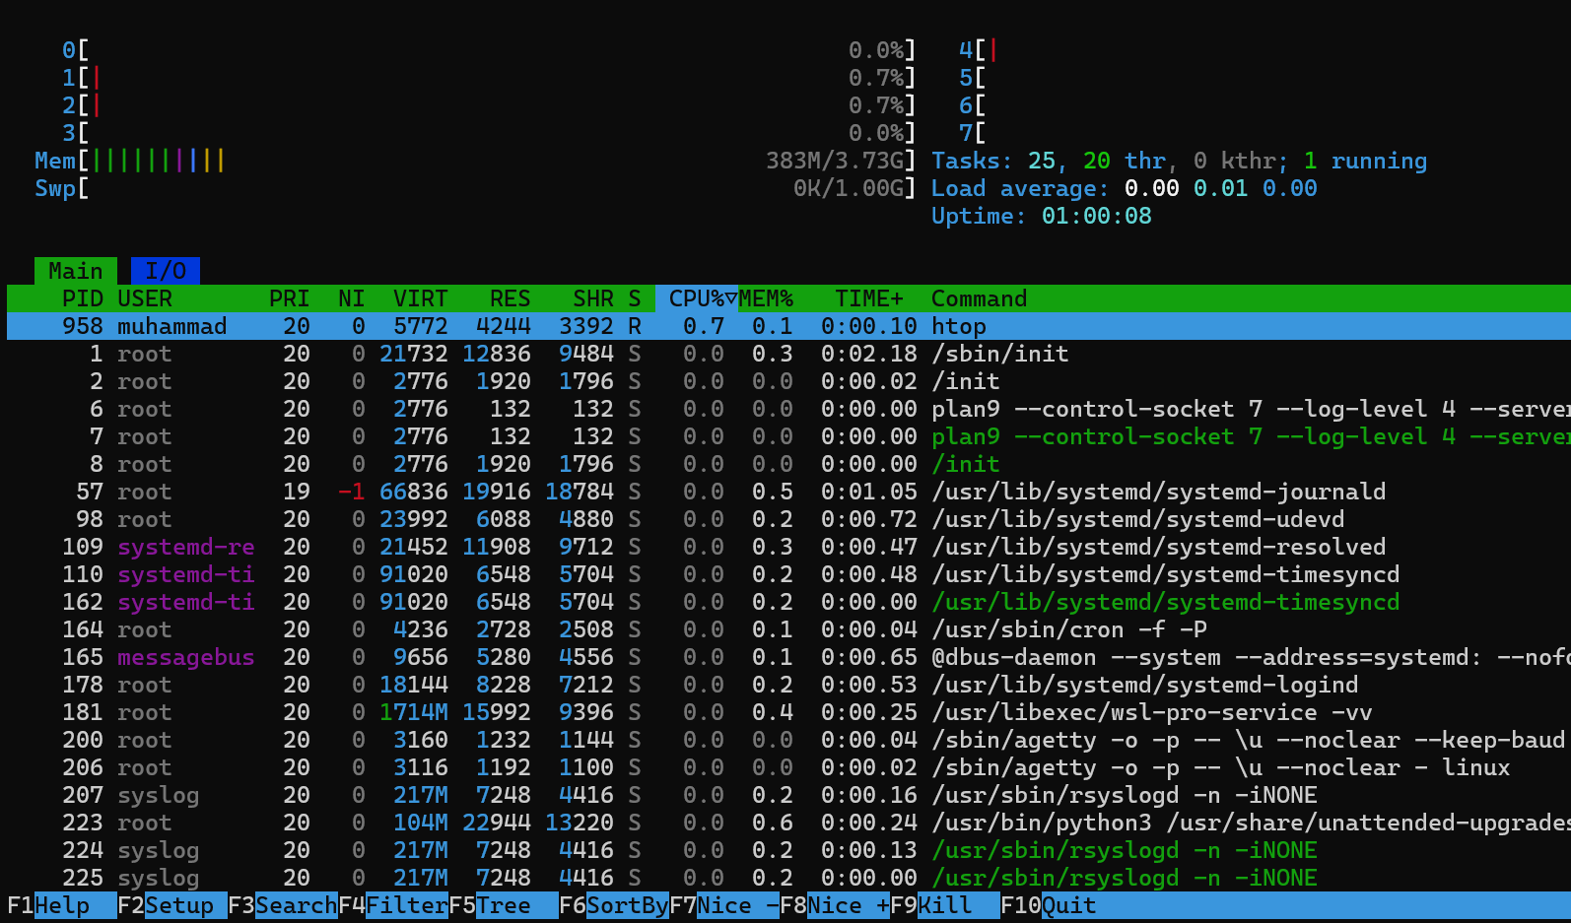

##### Manage Processes

* **Start a process in the background and view background jobs and Bring a background job to the foreground and Send a stopped job to the background:**

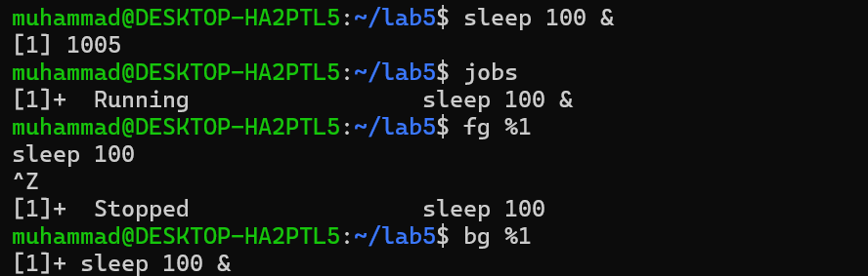

* **Find the PID of a process and Kill a process using PID:**



* **Kill a process by name:**



##### Adjust Process Priority

* **Start a process with a lower priority (higher nice value):**

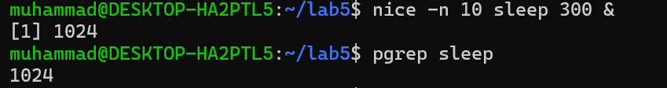

* **Change the priority of an existing process:**



* **Verify process priority:**

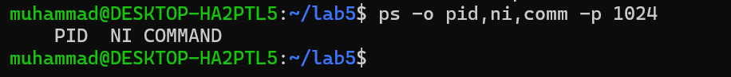

##### Monitor System Resource Usage

* **Check CPU and memory usage:**

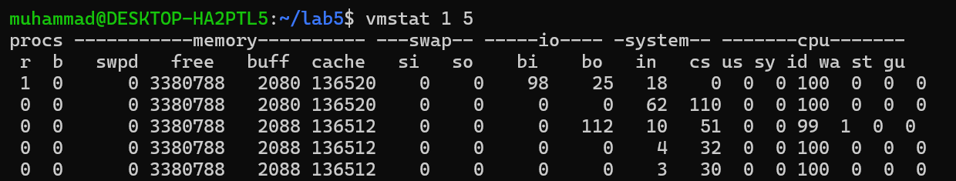

* 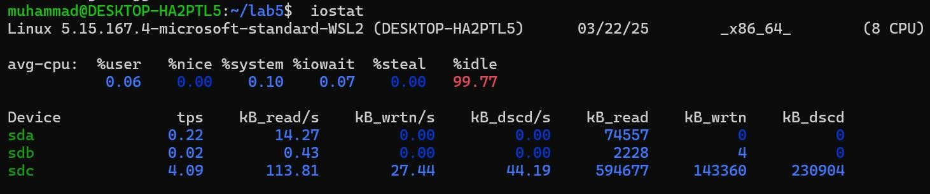**Monitor disk I/O usage:**
* 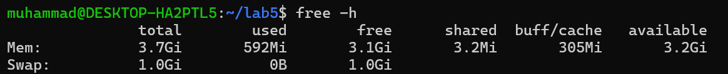**Monitor memory usage:**

**GENERALIZED LAB RUBRICS**

|  |  |  |  |  |  |  |  |  |
| --- | --- | --- | --- | --- | --- | --- | --- | --- |
| **Domain** | **Component with Taxonomy** | **Above Expectatio n (4)** | **Meeting Expectatio n (3)** | **Approachin g Expectation**  **(2)** | **Below Expectatio n (1)** | **Used** | **Weight / 100**  **(Optional)** | **Scor e (1–**  **4)** |
| **Psychomotor** | **Building (**Hardware) | Is able to build a given setup neatly and timely using correct hardware components and / or can reorganize / adapt to new / special  requirements | Is able to assemble a given setup using correct hardware components after minor revisions | Is only able to copy a given setup using correct hardware components | Is not able to assemble a given setup using correct hardware components | ☐ |  |  |
| **Cognitive** | **Recording Measuremen ts** (Hardware  / Software) | Is able to record accurate measurements all the time | Is able to record accurate measurements most of the time | Is only able to record accurate measurements on some occasions | Is unable to record accurate measurements | ☐ |  |  |
| **Investigation**  (Software) | Is able to formulate  /develop theories in addition to evaluating  /concluding correctly about investigation parameters by assessing data | Is able to evaluate  /conclude correctly about investigation parameters by assessing data | Is partially able to evaluate  /conclude correctly about investigation parameters by assessing data | Is unable to comprehen d investigatio n  parameters | ☐ |  |  |
| **Design / Development of Solution** (Hardware / Software) | Is able to design / develop the solution of a given problem and add features to it | Is able to design / develop the solution of a given problem | Is able to partially design / develop the solution of a given problem | Is unable to partially design / develop the solution of a given problem | ☐ |  |  |
| **Software Usage** (Software) | Is adept in the use of software tool and can access advanced features | Is able to use the software tool effectively by accessing all the required  features | Is able to use the software tool but cannot access all the required features | Is unable to use the software tool | ☐ |  |  |
| **Programming Language** (Software) | Is able to efficiently complete a given task using advanced programming language constructs  / methods / commands and/or add features to the  original task | Is able to complete a given task using required programming language constructs / methods / commands | Is able to partially complete a given task | Is unable to partially complete a given task | ☐ |  |  |

**GENERALIZED LAB RUBRICS**

|  |  |  |  |  |  |  |  |  |
| --- | --- | --- | --- | --- | --- | --- | --- | --- |
| **Domain** | **Component with Taxonomy** | **Above Expectatio n (4)** | **Meeting**  **Expectati on (3)** | **Approachin g Expectation**  **(2)** | **Below Expectatio n (1)** | **Use d** | **Weight / 100**  **(Optional)** | **Scor e (1–**  **4)** |
| **Affective** | **Safety Instruction s (PLO6)** | Assesses and complies with all EHS instructions  while in lab | Assesses and complies with most EHS instructions while  in lab | Assesses and complies with some EHS instructions while in lab | Assesses and complies with few EHS instructions in lab | ☐ |  |  |
| **Profession al Ethics (PLO8)** | Exhibits exemplary professional ethics while writing lab reports and dealing with fellow students, lab staff and instructor all the time | Exhibits professional ethics while writing lab reports and dealing with fellow students, lab staff and instructor all the time | Makes an effort to exhibit professional ethics while writing lab reports and dealing with fellow students, lab staff and instructor all the time | Does not exhibit professional ethics while writing lab reports and dealing with fellow students, lab staff and instructor all the  time | ☐ |  |  |
| **Contributio n (PLO9)** | Consistently shows full preparation by completing all agreed tasks and provides additional resources for the group and work  quality is excellent | Consistently shows full preparation by completing all agreed tasks and work requires little or no revisions | Shows some preparation which is mostly at superficial level in completing a task and work requires much revisions and editing | Shows very little or no preparation in completing a task and work quality is poor | ☐ |  |  |
| **Attitude (PLO9)** | Internalized positive behavior and encourages and helps other  team members | Consistent positive behavior most of the time towards other  team members | Neither helpful nor damaging and shows disinterest in the performance of  others | Discouraging behavior towards other team members | ☐ |  |  |
| **Report Writing (PLO10)** | Report on all relevant sections related to the lab tasks is completed accurately, meeting the requirements, in prescribed time and with good language skills | Report on all relevant sections related to the lab tasks is completed but few deficiencies are present in terms of accuracy / meeting the requirements / prescribed time / good language  skills | Report on all relevant sections related to the lab tasks is completed but many deficiencies are present in terms of accuracy / meeting the requirements / prescribed time / good language  skills | Report on all relevant sections related to the lab tasks is not completed | ☐ |  |  |
| **Lab Task Manageme nt (PLO11)** | Manages tasks well within given timeframe | Manages tasks within given timeframe | Manages tasks in an extended timeframe | Does not manage tasks even in extended timeframes | ☐ |  |  |

##### Lab 6: Shell Scripting Basics

**Objective:**

Write and execute simple shell scripts to automate tasks.

##### Creating and Running Shell Scripts

**Step 1: Create a new script file Step 2: Edit the script file**

**Step 3: Make the script executable Step 4: Run the script**

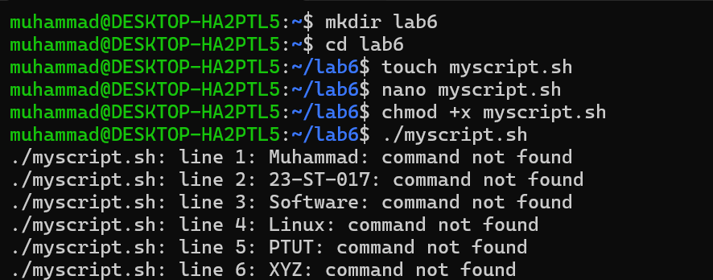

##### Using Variables and Simple Control Structures

* **Define and use variables in a script**

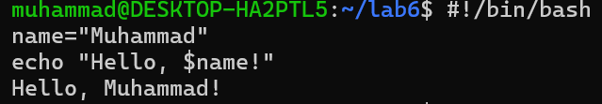

* **Use conditional statements**

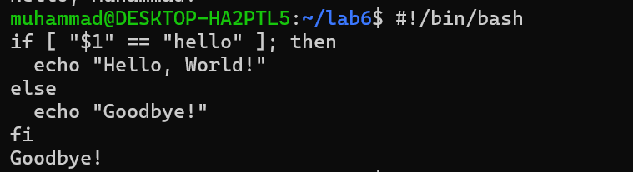

* **Use loops in a script**

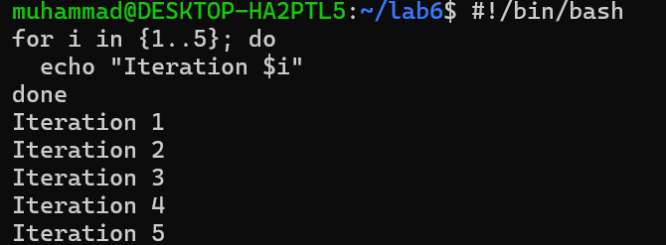

##### Input/Output Redirection

* 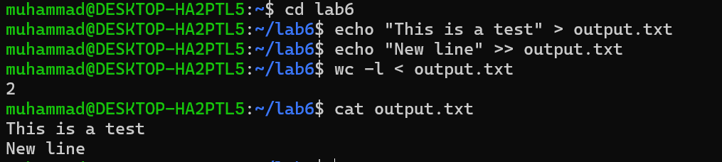**Redirect output to a file and Redirect input from a file and append output to file.**

##### Automating Daily Tasks with Scripts

* **Write a backup script**

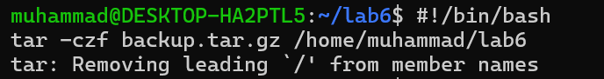

* **Schedule the script with cron**

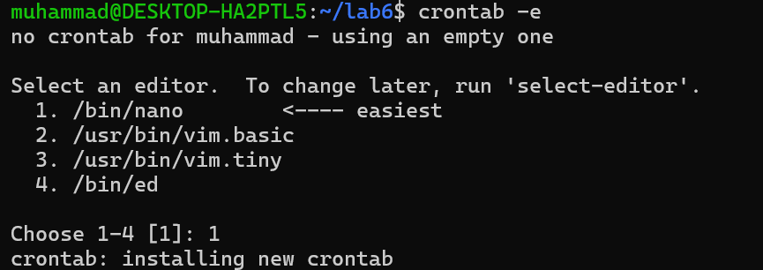

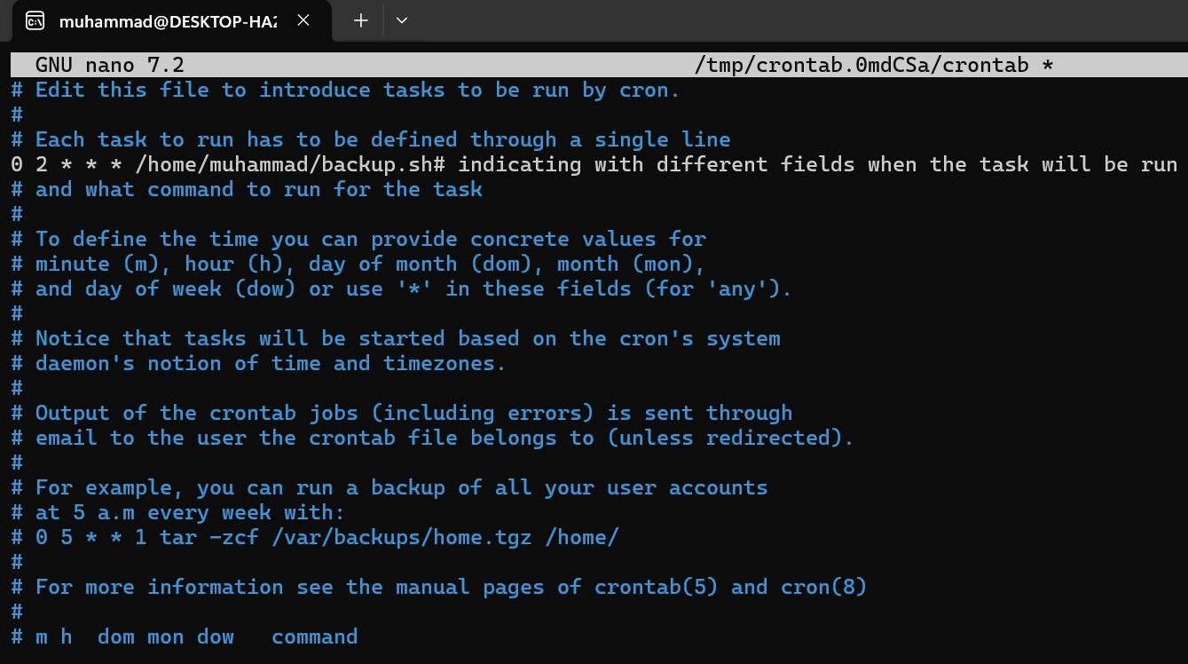

* **Verify Scheduled Jobs**

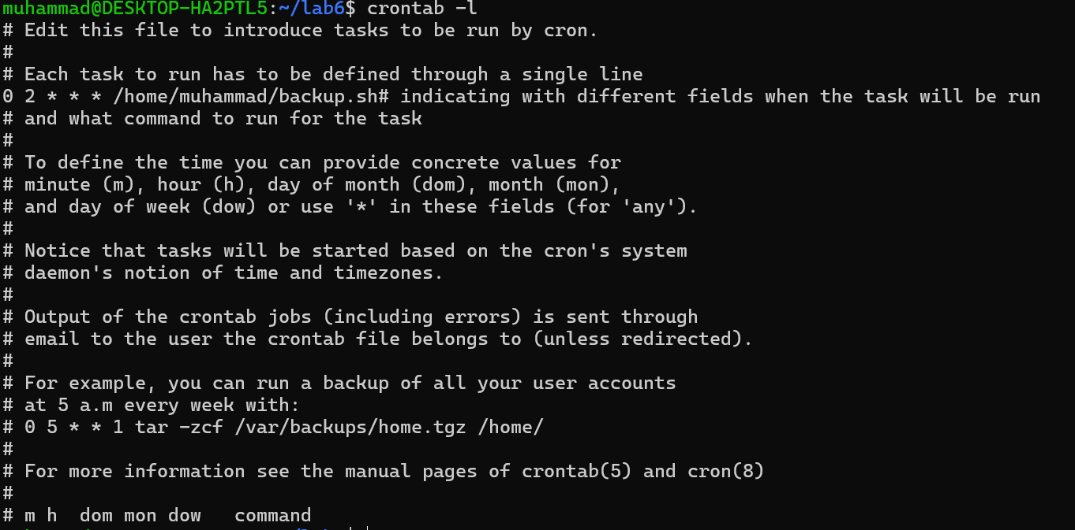

##### Monitoring System Performance

* **Check CPU and Memory Usage**

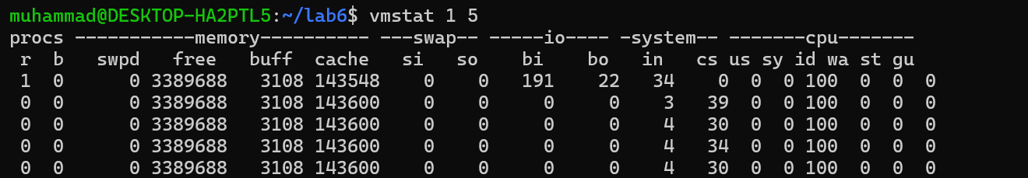

* **Monitor Disk I/O Usage**

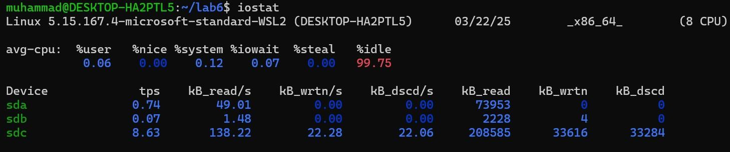

* **Check Available Memory**

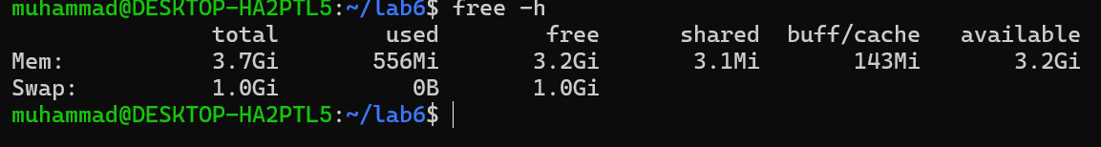

**GENERALIZED LAB RUBRICS**

|  |  |  |  |  |  |  |  |  |
| --- | --- | --- | --- | --- | --- | --- | --- | --- |
| **Domain** | **Component with Taxonomy** | **Above Expectatio n (4)** | **Meeting Expectatio n (3)** | **Approachin g Expectation**  **(2)** | **Below Expectatio n (1)** | **Used** | **Weight / 100**  **(Optional)** | **Scor e (1–**  **4)** |
| **Psychomotor** | **Building (**Hardware) | Is able to build a given setup neatly and timely using correct hardware components and / or can reorganize / adapt to new / special  requirements | Is able to assemble a given setup using correct hardware components after minor revisions | Is only able to copy a given setup using correct hardware components | Is not able to assemble a given setup using correct hardware components | ☐ |  |  |
| **Cognitive** | **Recording Measuremen ts** (Hardware  / Software) | Is able to record accurate measurements all the time | Is able to record accurate measurements most of the time | Is only able to record accurate measurements on some occasions | Is unable to record accurate measurements | ☐ |  |  |
| **Investigation**  (Software) | Is able to formulate  /develop theories in addition to evaluating  /concluding correctly about investigation parameters by assessing data | Is able to evaluate  /conclude correctly about investigation parameters by assessing data | Is partially able to evaluate  /conclude correctly about investigation parameters by assessing data | Is unable to comprehen d investigatio n  parameters | ☐ |  |  |
| **Design / Development of Solution** (Hardware / Software) | Is able to design / develop the solution of a given problem and add features to it | Is able to design / develop the solution of a given problem | Is able to partially design / develop the solution of a given problem | Is unable to partially design / develop the solution of a given problem | ☐ |  |  |
| **Software Usage** (Software) | Is adept in the use of software tool and can access advanced features | Is able to use the software tool effectively by accessing all the required  features | Is able to use the software tool but cannot access all the required features | Is unable to use the software tool | ☐ |  |  |
| **Programming Language** (Software) | Is able to efficiently complete a given task using advanced programming language constructs  / methods / commands and/or add features to the  original task | Is able to complete a given task using required programming language constructs / methods / commands | Is able to partially complete a given task | Is unable to partially complete a given task | ☐ |  |  |

**GENERALIZED LAB RUBRICS**

|  |  |  |  |  |  |  |  |  |
| --- | --- | --- | --- | --- | --- | --- | --- | --- |
| **Domain** | **Component with Taxonomy** | **Above Expectatio n (4)** | **Meeting**  **Expectati on (3)** | **Approachin g Expectation**  **(2)** | **Below Expectatio n (1)** | **Use d** | **Weight / 100**  **(Optional)** | **Scor e (1–**  **4)** |
| **Affective** | **Safety Instruction s (PLO6)** | Assesses and complies with all EHS instructions  while in lab | Assesses and complies with most EHS instructions while  in lab | Assesses and complies with some EHS instructions while in lab | Assesses and complies with few EHS instructions in lab | ☐ |  |  |
| **Profession al Ethics (PLO8)** | Exhibits exemplary professional ethics while writing lab reports and dealing with fellow students, lab staff and instructor all the time | Exhibits professional ethics while writing lab reports and dealing with fellow students, lab staff and instructor all the time | Makes an effort to exhibit professional ethics while writing lab reports and dealing with fellow students, lab staff and instructor all the time | Does not exhibit professional ethics while writing lab reports and dealing with fellow students, lab staff and instructor all the  time | ☐ |  |  |
| **Contributio n (PLO9)** | Consistently shows full preparation by completing all agreed tasks and provides additional resources for the group and work  quality is excellent | Consistently shows full preparation by completing all agreed tasks and work requires little or no revisions | Shows some preparation which is mostly at superficial level in completing a task and work requires much revisions and editing | Shows very little or no preparation in completing a task and work quality is poor | ☐ |  |  |
| **Attitude (PLO9)** | Internalized positive behavior and encourages and helps other  team members | Consistent positive behavior most of the time towards other  team members | Neither helpful nor damaging and shows disinterest in the performance of  others | Discouraging behavior towards other team members | ☐ |  |  |
| **Report Writing (PLO10)** | Report on all relevant sections related to the lab tasks is completed accurately, meeting the requirements, in prescribed time and with good language skills | Report on all relevant sections related to the lab tasks is completed but few deficiencies are present in terms of accuracy / meeting the requirements / prescribed time / good language  skills | Report on all relevant sections related to the lab tasks is completed but many deficiencies are present in terms of accuracy / meeting the requirements / prescribed time / good language  skills | Report on all relevant sections related to the lab tasks is not completed | ☐ |  |  |
| **Lab Task Manageme nt (PLO11)** | Manages tasks well within given timeframe | Manages tasks within given timeframe | Manages tasks in an extended timeframe | Does not manage tasks even in extended timeframes | ☐ |  |  |

##### Lab 7: Advanced Shell Scripting

**Objective:**

Explore advanced shell scripting techniques including loops, conditionals, functions, and task scheduling.

##### Loops and Conditional Statements

* **Using for and while loops**

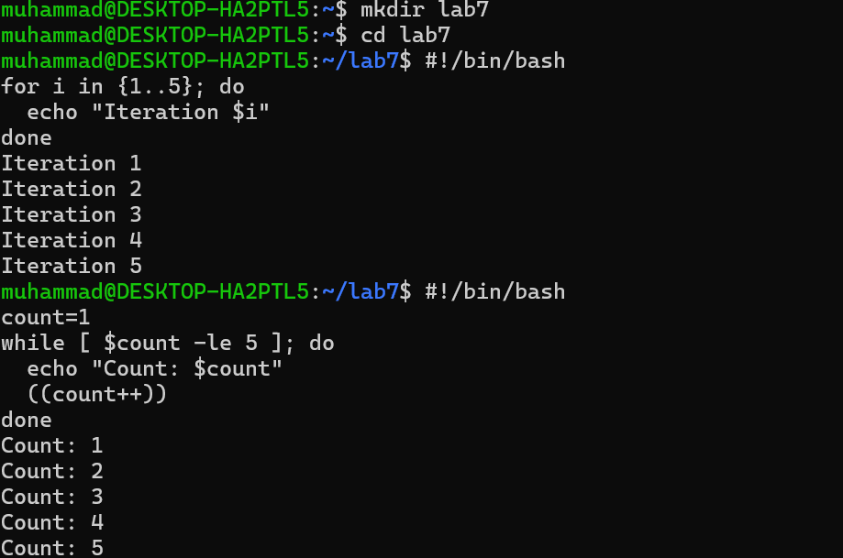

* **Using if statements**

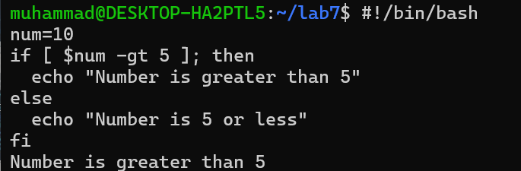

* **Using case statements**

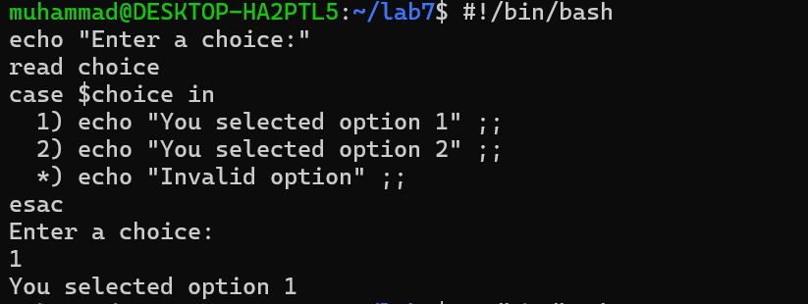

##### Functions in Shell Scripts

* **Defining and calling functions**

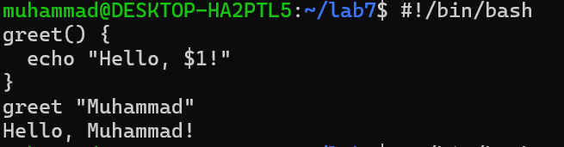

##### Automating Tasks with Crontab

* **Write a system monitoring script**

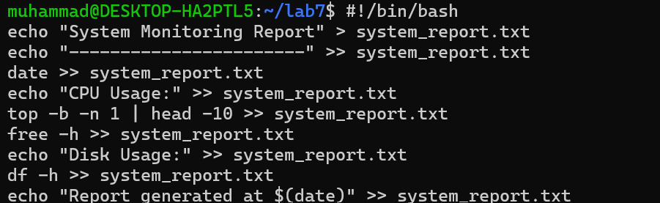

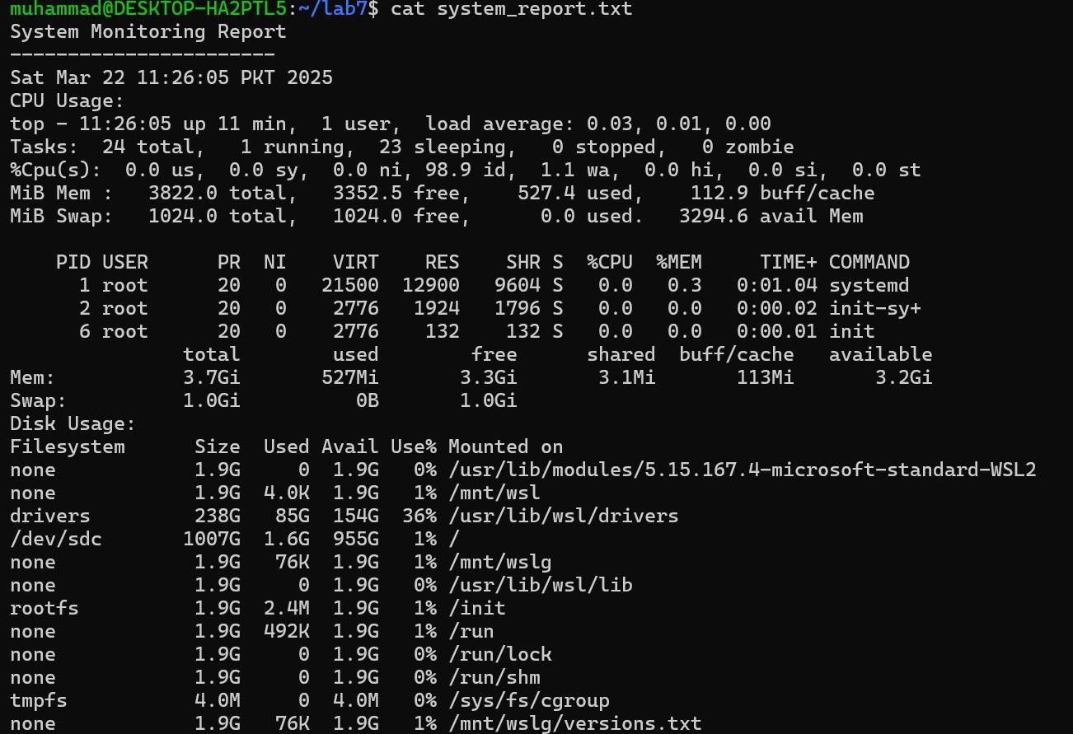

* 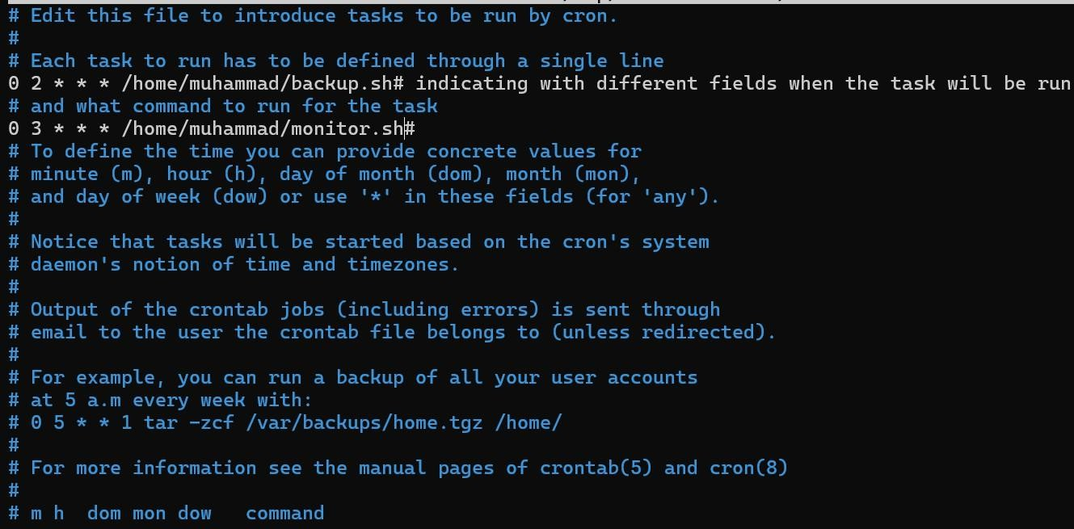**Schedule the script using crontab**



* **Verify Scheduled Jobs**

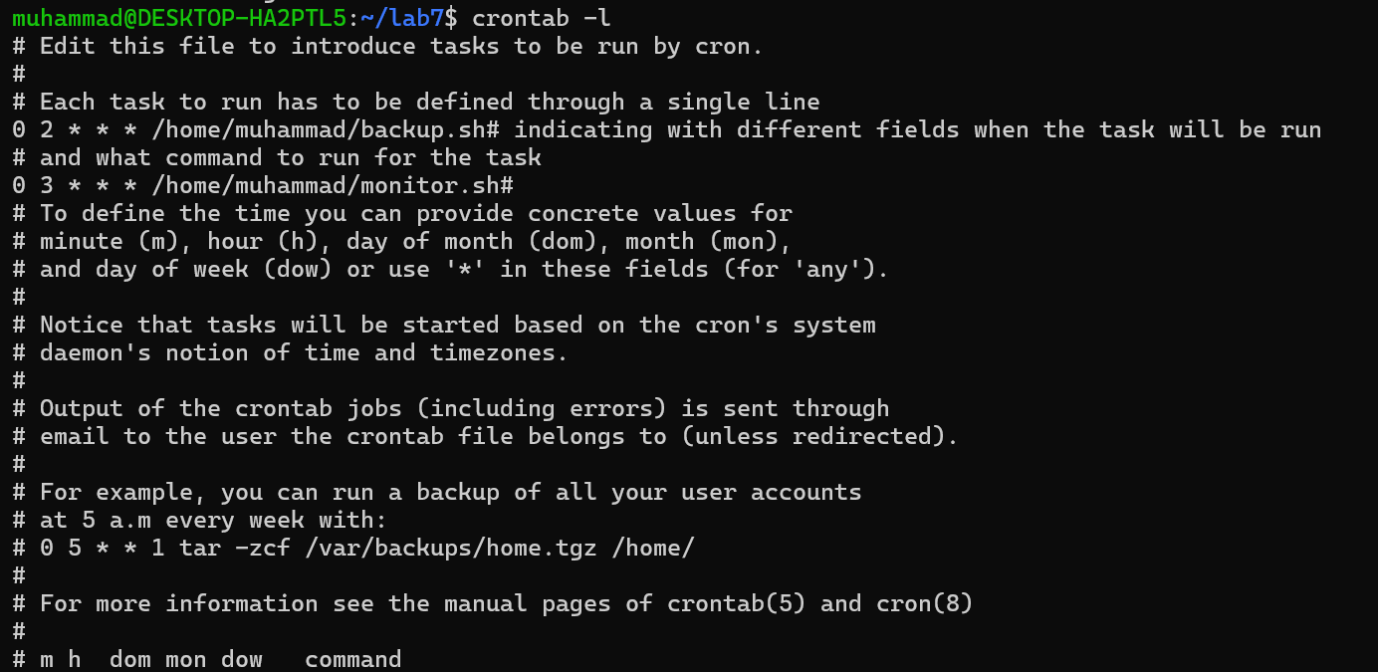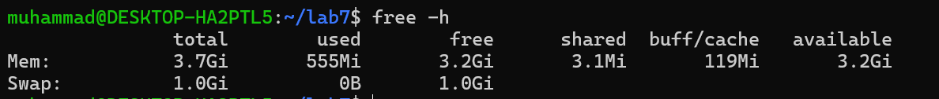

##### Monitoring System Performance

* 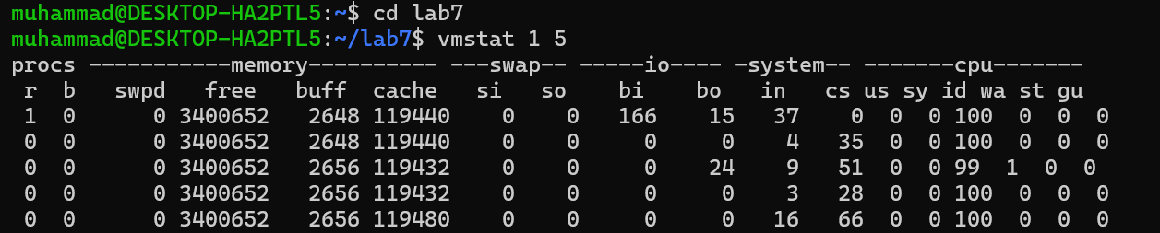**Check CPU and Memory Usage**
* **Monitor Disk I/O Usage**

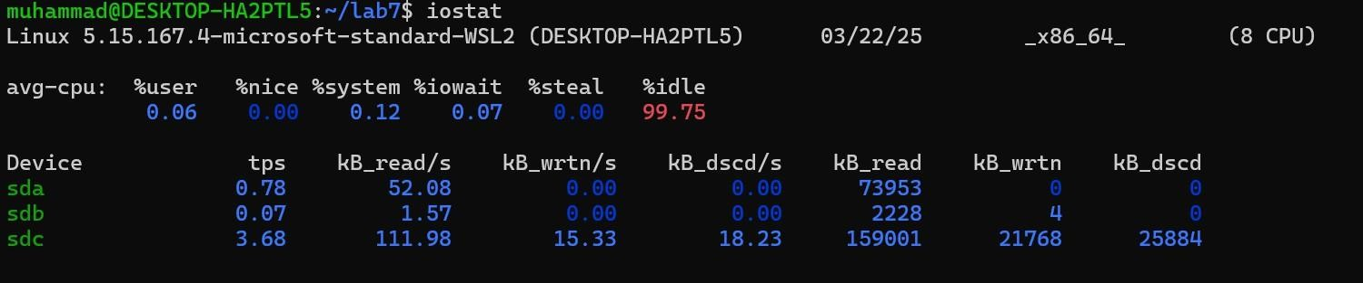

* **Check Available Memory**

**GENERALIZED LAB RUBRICS**

|  |  |  |  |  |  |  |  |  |
| --- | --- | --- | --- | --- | --- | --- | --- | --- |
| **Domain** | **Component with Taxonomy** | **Above Expectatio n (4)** | **Meeting Expectatio n (3)** | **Approachin g Expectation**  **(2)** | **Below Expectatio n (1)** | **Used** | **Weight / 100**  **(Optional)** | **Scor e (1–**  **4)** |
| **Psychomotor** | **Building (**Hardware) | Is able to build a given setup neatly and timely using correct hardware components and / or can reorganize / adapt to new / special  requirements | Is able to assemble a given setup using correct hardware components after minor revisions | Is only able to copy a given setup using correct hardware components | Is not able to assemble a given setup using correct hardware components | ☐ |  |  |
| **Cognitive** | **Recording Measuremen ts** (Hardware  / Software) | Is able to record accurate measurements all the time | Is able to record accurate measurements most of the time | Is only able to record accurate measurements on some occasions | Is unable to record accurate measurements | ☐ |  |  |
| **Investigation**  (Software) | Is able to formulate  /develop theories in addition to evaluating  /concluding correctly about investigation parameters by assessing data | Is able to evaluate  /conclude correctly about investigation parameters by assessing data | Is partially able to evaluate  /conclude correctly about investigation parameters by assessing data | Is unable to comprehen d investigatio n  parameters | ☐ |  |  |
| **Design / Development of Solution** (Hardware / Software) | Is able to design / develop the solution of a given problem and add features to it | Is able to design / develop the solution of a given problem | Is able to partially design / develop the solution of a given problem | Is unable to partially design / develop the solution of a given problem | ☐ |  |  |
| **Software Usage** (Software) | Is adept in the use of software tool and can access advanced features | Is able to use the software tool effectively by accessing all the required  features | Is able to use the software tool but cannot access all the required features | Is unable to use the software tool | ☐ |  |  |
| **Programming Language** (Software) | Is able to efficiently complete a given task using advanced programming language constructs  / methods / commands and/or add features to the  original task | Is able to complete a given task using required programming language constructs / methods / commands | Is able to partially complete a given task | Is unable to partially complete a given task | ☐ |  |  |

**GENERALIZED LAB RUBRICS**

|  |  |  |  |  |  |  |  |  |
| --- | --- | --- | --- | --- | --- | --- | --- | --- |
| **Domain** | **Component with Taxonomy** | **Above Expectatio n (4)** | **Meeting**  **Expectati on (3)** | **Approachin g Expectation**  **(2)** | **Below Expectatio n (1)** | **Use d** | **Weight / 100**  **(Optional)** | **Scor e (1–**  **4)** |
| **Affective** | **Safety Instruction s (PLO6)** | Assesses and complies with all EHS instructions  while in lab | Assesses and complies with most EHS instructions while  in lab | Assesses and complies with some EHS instructions while in lab | Assesses and complies with few EHS instructions in lab | ☐ |  |  |
| **Profession al Ethics (PLO8)** | Exhibits exemplary professional ethics while writing lab reports and dealing with fellow students, lab staff and instructor all the time | Exhibits professional ethics while writing lab reports and dealing with fellow students, lab staff and instructor all the time | Makes an effort to exhibit professional ethics while writing lab reports and dealing with fellow students, lab staff and instructor all the time | Does not exhibit professional ethics while writing lab reports and dealing with fellow students, lab staff and instructor all the  time | ☐ |  |  |
| **Contributio n (PLO9)** | Consistently shows full preparation by completing all agreed tasks and provides additional resources for the group and work  quality is excellent | Consistently shows full preparation by completing all agreed tasks and work requires little or no revisions | Shows some preparation which is mostly at superficial level in completing a task and work requires much revisions and editing | Shows very little or no preparation in completing a task and work quality is poor | ☐ |  |  |
| **Attitude (PLO9)** | Internalized positive behavior and encourages and helps other  team members | Consistent positive behavior most of the time towards other  team members | Neither helpful nor damaging and shows disinterest in the performance of  others | Discouraging behavior towards other team members | ☐ |  |  |
| **Report Writing (PLO10)** | Report on all relevant sections related to the lab tasks is completed accurately, meeting the requirements, in prescribed time and with good language skills | Report on all relevant sections related to the lab tasks is completed but few deficiencies are present in terms of accuracy / meeting the requirements / prescribed time / good language  skills | Report on all relevant sections related to the lab tasks is completed but many deficiencies are present in terms of accuracy / meeting the requirements / prescribed time / good language  skills | Report on all relevant sections related to the lab tasks is not completed | ☐ |  |  |
| **Lab Task Manageme nt (PLO11)** | Manages tasks well within given timeframe | Manages tasks within given timeframe | Manages tasks in an extended timeframe | Does not manage tasks even in extended timeframes | ☐ |  |  |

##### Lab 8: Package Management

**Objective:**

Learn how to install, update, and manage software packages using different package managers.

##### Understanding Package Managers

Package managers help in installing, updating, and removing software efficiently. Different Linux distributions use different package managers:

* **APT (apt)** – Used in Debian-based systems like Ubuntu.
* **YUM (yum)** and **DNF (dnf)** – Used in Red Hat-based systems like CentOS and Fedora.

##### Installing Software Packages

* **Ubuntu/Debian (apt):**

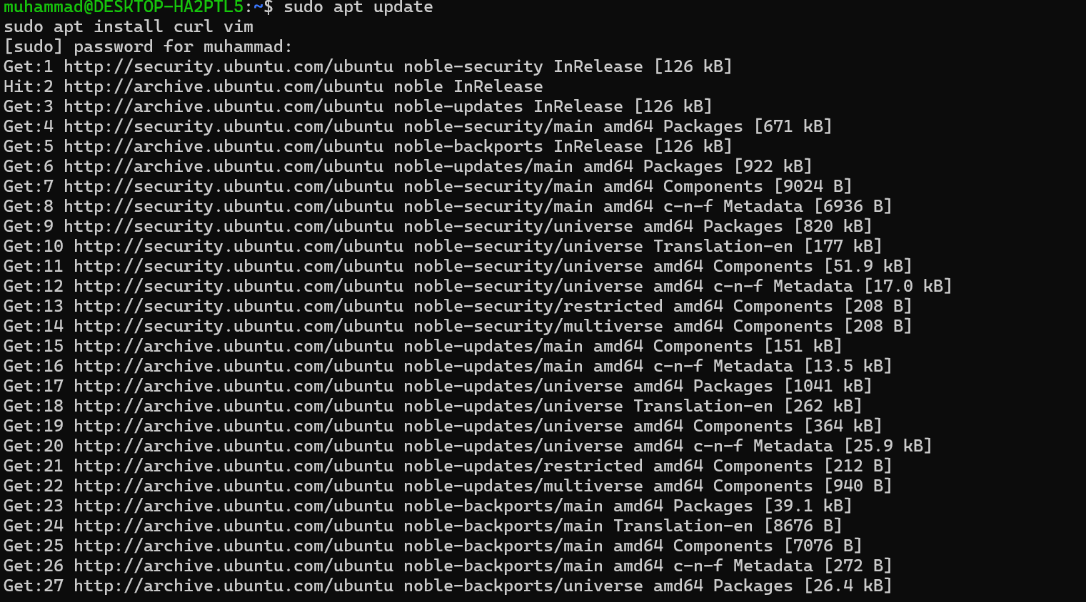

##### Updating and Removing Packages

* **Update all installed packages:**
* **For Ubuntu/Debian:**

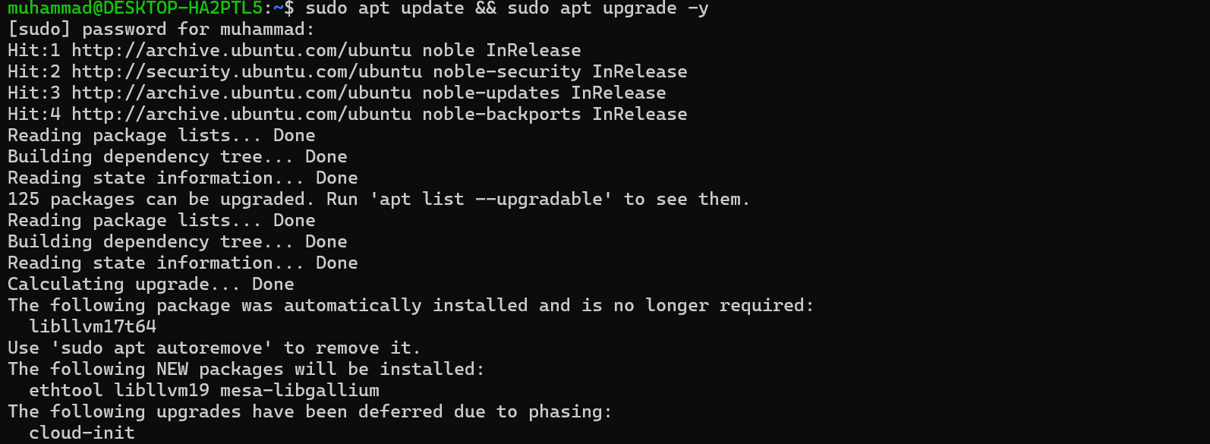

* **Remove an installed package:**
* **For Ubuntu/Debian:**

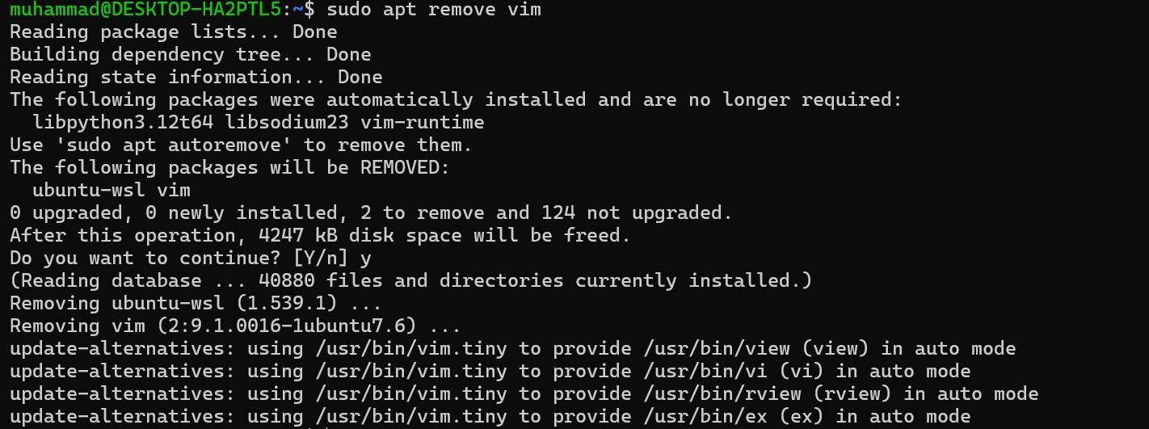

##### Cleaning Up Unused Packages

To free up space and remove unnecessary dependencies:

* **For Ubuntu/Debian:**

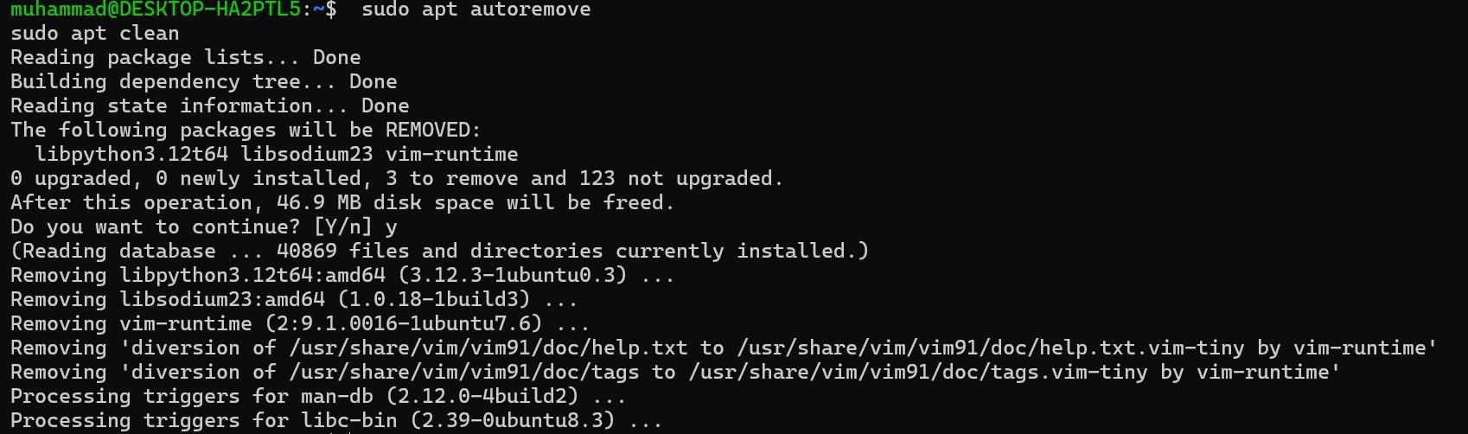

##### Managing Repositories

Repositories store software packages and updates. You can list available repositories:

* **For Ubuntu/Debian:**

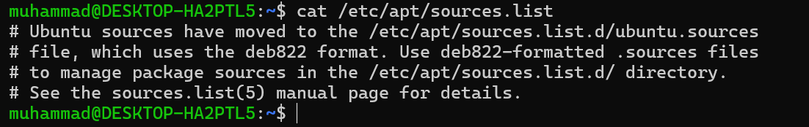

##### Verify Installed Packages

* **For Ubuntu/Debian:**

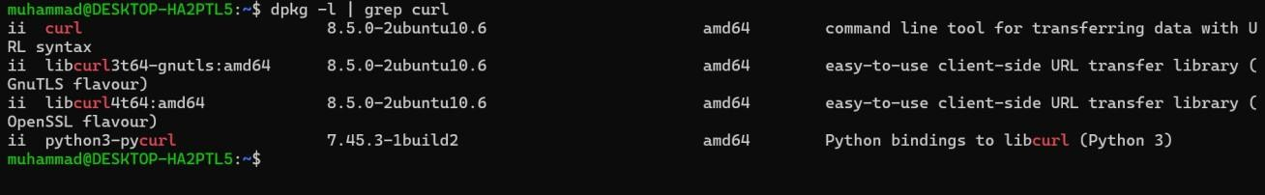

**GENERALIZED LAB RUBRICS**

|  |  |  |  |  |  |  |  |  |
| --- | --- | --- | --- | --- | --- | --- | --- | --- |
| **Domain** | **Component with Taxonomy** | **Above Expectatio n (4)** | **Meeting Expectatio n (3)** | **Approachin g Expectation**  **(2)** | **Below Expectatio n (1)** | **Used** | **Weight / 100**  **(Optional)** | **Scor e (1–**  **4)** |
| **Psychomotor** | **Building (**Hardware) | Is able to build a given setup neatly and timely using correct hardware components and / or can reorganize / adapt to new / special  requirements | Is able to assemble a given setup using correct hardware components after minor revisions | Is only able to copy a given setup using correct hardware components | Is not able to assemble a given setup using correct hardware components | ☐ |  |  |
| **Cognitive** | **Recording Measuremen ts** (Hardware  / Software) | Is able to record accurate measurements all the time | Is able to record accurate measurements most of the time | Is only able to record accurate measurements on some occasions | Is unable to record accurate measurements | ☐ |  |  |
| **Investigation**  (Software) | Is able to formulate  /develop theories in addition to evaluating  /concluding correctly about investigation parameters by assessing data | Is able to evaluate  /conclude correctly about investigation parameters by assessing data | Is partially able to evaluate  /conclude correctly about investigation parameters by assessing data | Is unable to comprehen d investigatio n  parameters | ☐ |  |  |
| **Design / Development of Solution** (Hardware / Software) | Is able to design / develop the solution of a given problem and add features to it | Is able to design / develop the solution of a given problem | Is able to partially design / develop the solution of a given problem | Is unable to partially design / develop the solution of a given problem | ☐ |  |  |
| **Software Usage** (Software) | Is adept in the use of software tool and can access advanced features | Is able to use the software tool effectively by accessing all the required  features | Is able to use the software tool but cannot access all the required features | Is unable to use the software tool | ☐ |  |  |
| **Programming Language** (Software) | Is able to efficiently complete a given task using advanced programming language constructs  / methods / commands and/or add features to the  original task | Is able to complete a given task using required programming language constructs / methods / commands | Is able to partially complete a given task | Is unable to partially complete a given task | ☐ |  |  |

**GENERALIZED LAB RUBRICS**

|  |  |  |  |  |  |  |  |  |
| --- | --- | --- | --- | --- | --- | --- | --- | --- |
| **Domain** | **Component with Taxonomy** | **Above Expectatio n (4)** | **Meeting**  **Expectati on (3)** | **Approachin g Expectation**  **(2)** | **Below Expectatio n (1)** | **Use d** | **Weight / 100**  **(Optional)** | **Scor e (1–**  **4)** |
| **Affective** | **Safety Instruction s (PLO6)** | Assesses and complies with all EHS instructions  while in lab | Assesses and complies with most EHS instructions while  in lab | Assesses and complies with some EHS instructions while in lab | Assesses and complies with few EHS instructions in lab | ☐ |  |  |
| **Profession al Ethics (PLO8)** | Exhibits exemplary professional ethics while writing lab reports and dealing with fellow students, lab staff and instructor all the time | Exhibits professional ethics while writing lab reports and dealing with fellow students, lab staff and instructor all the time | Makes an effort to exhibit professional ethics while writing lab reports and dealing with fellow students, lab staff and instructor all the time | Does not exhibit professional ethics while writing lab reports and dealing with fellow students, lab staff and instructor all the  time | ☐ |  |  |
| **Contributio n (PLO9)** | Consistently shows full preparation by completing all agreed tasks and provides additional resources for the group and work  quality is excellent | Consistently shows full preparation by completing all agreed tasks and work requires little or no revisions | Shows some preparation which is mostly at superficial level in completing a task and work requires much revisions and editing | Shows very little or no preparation in completing a task and work quality is poor | ☐ |  |  |
| **Attitude (PLO9)** | Internalized positive behavior and encourages and helps other  team members | Consistent positive behavior most of the time towards other  team members | Neither helpful nor damaging and shows disinterest in the performance of  others | Discouraging behavior towards other team members | ☐ |  |  |
| **Report Writing (PLO10)** | Report on all relevant sections related to the lab tasks is completed accurately, meeting the requirements, in prescribed time and with good language skills | Report on all relevant sections related to the lab tasks is completed but few deficiencies are present in terms of accuracy / meeting the requirements / prescribed time / good language  skills | Report on all relevant sections related to the lab tasks is completed but many deficiencies are present in terms of accuracy / meeting the requirements / prescribed time / good language  skills | Report on all relevant sections related to the lab tasks is not completed | ☐ |  |  |
| **Lab Task Manageme nt (PLO11)** | Manages tasks well within given timeframe | Manages tasks within given timeframe | Manages tasks in an extended timeframe | Does not manage tasks even in extended timeframes | ☐ |  |  |

##### Lab 9: Disk and Partition Management Objective:

Learn disk and partition management basics, including disk space usage, mounting/unmounting file systems, and partitioning.

##### Checking Disk Space Usage

* + 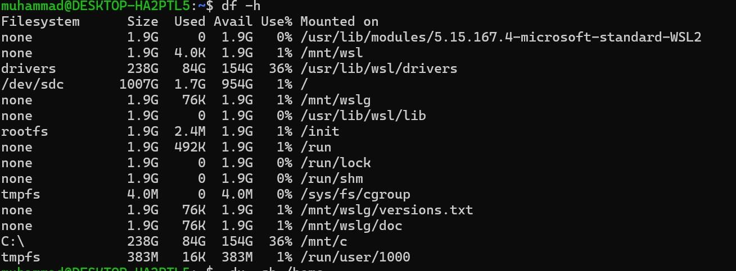**Check Overall Disk Space (df command)**
* -h flag shows human-readable format (GB, MB).
* This command lists mounted file systems and available space.
  + 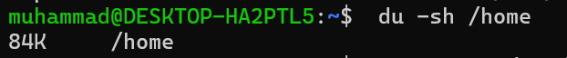**Check Disk Usage in a Specific Folder (du command).**

##### Mounting and Unmounting a USB Drive:

* + **Mount the USB Drive in WSL and verify**

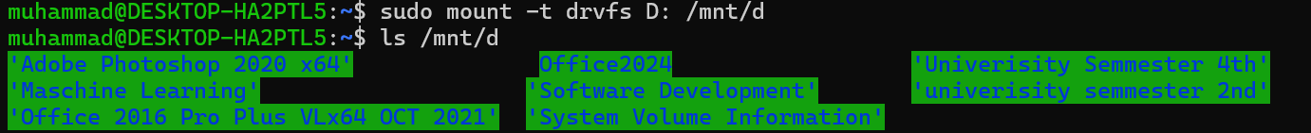

* + 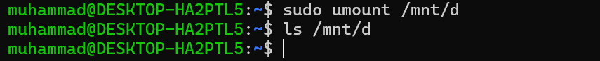**Unmount the USB Drive Safely**

##### Partitioning a Drive and Mount and Unmount USB

* + **Create a new partition**
* Type n (new partition)
* Choose p (primary partition)
* Press **Enter** to accept default values for size
* Type w to write changes and exit

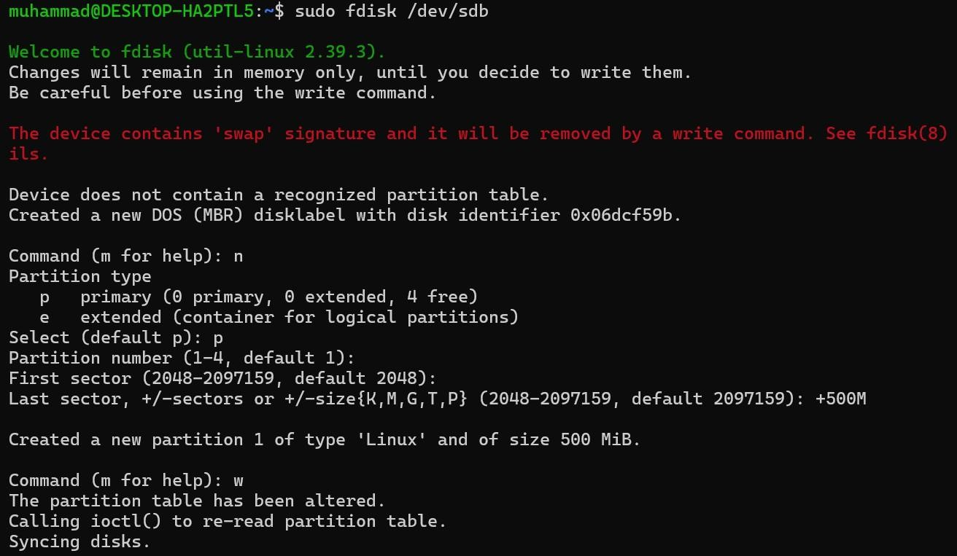

* + **Format the partition**

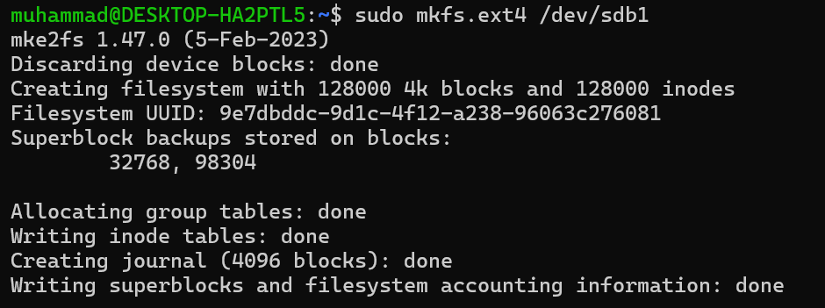

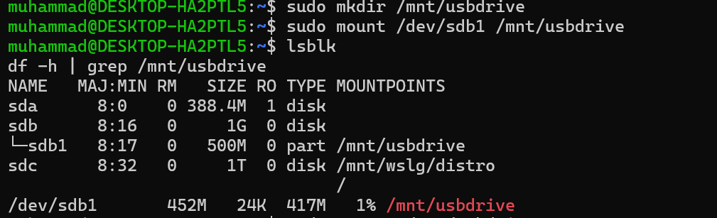**Mount the Partition:**

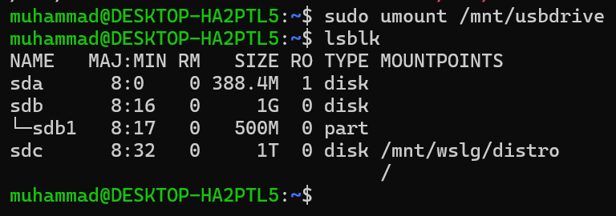**Unmount the USB Drive:**

**GENERALIZED LAB RUBRICS**

|  |  |  |  |  |  |  |  |  |
| --- | --- | --- | --- | --- | --- | --- | --- | --- |
| **Domain** | **Component with Taxonomy** | **Above Expectatio n (4)** | **Meeting Expectatio n (3)** | **Approachin g Expectation**  **(2)** | **Below Expectatio n (1)** | **Used** | **Weight / 100**  **(Optional)** | **Scor e (1–**  **4)** |
| **Psychomotor** | **Building (**Hardware) | Is able to build a given setup neatly and timely using correct hardware components and / or can reorganize / adapt to new / special  requirements | Is able to assemble a given setup using correct hardware components after minor revisions | Is only able to copy a given setup using correct hardware components | Is not able to assemble a given setup using correct hardware components | ☐ |  |  |
| **Cognitive** | **Recording Measuremen ts** (Hardware  / Software) | Is able to record accurate measurements all the time | Is able to record accurate measurements most of the time | Is only able to record accurate measurements on some occasions | Is unable to record accurate measurements | ☐ |  |  |
| **Investigation**  (Software) | Is able to formulate  /develop theories in addition to evaluating  /concluding correctly about investigation parameters by assessing data | Is able to evaluate  /conclude correctly about investigation parameters by assessing data | Is partially able to evaluate  /conclude correctly about investigation parameters by assessing data | Is unable to comprehen d investigatio n  parameters | ☐ |  |  |
| **Design / Development of Solution** (Hardware / Software) | Is able to design / develop the solution of a given problem and add features to it | Is able to design / develop the solution of a given problem | Is able to partially design / develop the solution of a given problem | Is unable to partially design / develop the solution of a given problem | ☐ |  |  |
| **Software Usage** (Software) | Is adept in the use of software tool and can access advanced features | Is able to use the software tool effectively by accessing all the required  features | Is able to use the software tool but cannot access all the required features | Is unable to use the software tool | ☐ |  |  |
| **Programming Language** (Software) | Is able to efficiently complete a given task using advanced programming language constructs  / methods / commands and/or add features to the  original task | Is able to complete a given task using required programming language constructs / methods / commands | Is able to partially complete a given task | Is unable to partially complete a given task | ☐ |  |  |

**GENERALIZED LAB RUBRICS**

|  |  |  |  |  |  |  |  |  |
| --- | --- | --- | --- | --- | --- | --- | --- | --- |
| **Domain** | **Component with Taxonomy** | **Above Expectatio n (4)** | **Meeting**  **Expectati on (3)** | **Approachin g Expectation**  **(2)** | **Below Expectatio n (1)** | **Use d** | **Weight / 100**  **(Optional)** | **Scor e (1–**  **4)** |
| **Affective** | **Safety Instruction s (PLO6)** | Assesses and complies with all EHS instructions  while in lab | Assesses and complies with most EHS instructions while  in lab | Assesses and complies with some EHS instructions while in lab | Assesses and complies with few EHS instructions in lab | ☐ |  |  |
| **Profession al Ethics (PLO8)** | Exhibits exemplary professional ethics while writing lab reports and dealing with fellow students, lab staff and instructor all the time | Exhibits professional ethics while writing lab reports and dealing with fellow students, lab staff and instructor all the time | Makes an effort to exhibit professional ethics while writing lab reports and dealing with fellow students, lab staff and instructor all the time | Does not exhibit professional ethics while writing lab reports and dealing with fellow students, lab staff and instructor all the  time | ☐ |  |  |
| **Contributio n (PLO9)** | Consistently shows full preparation by completing all agreed tasks and provides additional resources for the group and work  quality is excellent | Consistently shows full preparation by completing all agreed tasks and work requires little or no revisions | Shows some preparation which is mostly at superficial level in completing a task and work requires much revisions and editing | Shows very little or no preparation in completing a task and work quality is poor | ☐ |  |  |
| **Attitude (PLO9)** | Internalized positive behavior and encourages and helps other  team members | Consistent positive behavior most of the time towards other  team members | Neither helpful nor damaging and shows disinterest in the performance of  others | Discouraging behavior towards other team members | ☐ |  |  |
| **Report Writing (PLO10)** | Report on all relevant sections related to the lab tasks is completed accurately, meeting the requirements, in prescribed time and with good language skills | Report on all relevant sections related to the lab tasks is completed but few deficiencies are present in terms of accuracy / meeting the requirements / prescribed time / good language  skills | Report on all relevant sections related to the lab tasks is completed but many deficiencies are present in terms of accuracy / meeting the requirements / prescribed time / good language  skills | Report on all relevant sections related to the lab tasks is not completed | ☐ |  |  |
| **Lab Task Manageme nt (PLO11)** | Manages tasks well within given timeframe | Manages tasks within given timeframe | Manages tasks in an extended timeframe | Does not manage tasks even in extended timeframes | ☐ |  |  |

##### Lab 10: Networking Basics

**Objective:**

Configure and troubleshoot network settings.

##### Topics:

* Understanding IP addresses and network interfaces.
* Using `ifconfig`, `ip`, `ping`, `netstat`.
* SSH basics and file transfer (`scp`).

##### Check Network Interfaces

* + 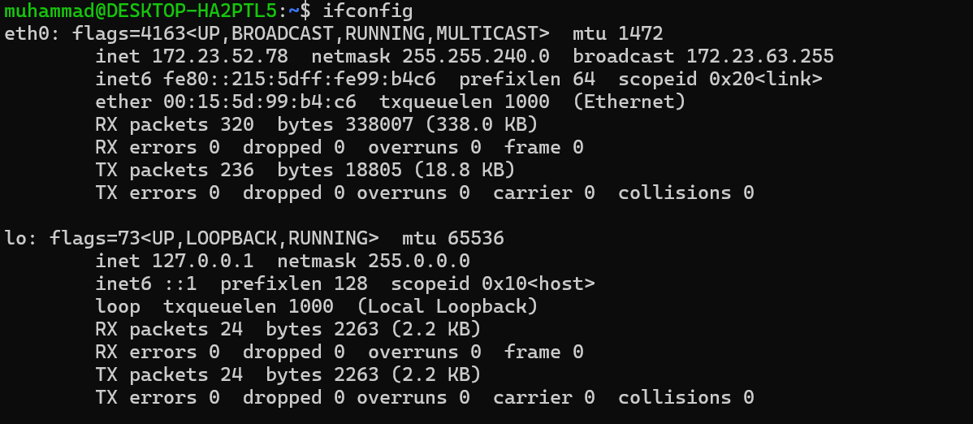Shows current network interfaces and their IP addresses.
  + Displays detailed IP and interface information.

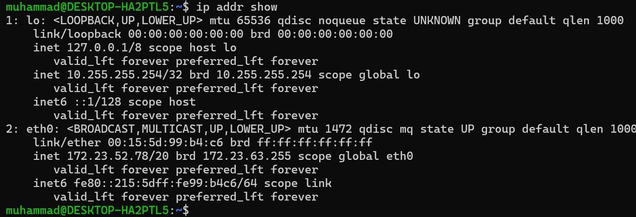

##### . Check Internet Connection with Ping

* Tests network connectivity to the internet.

##### View Network Stats

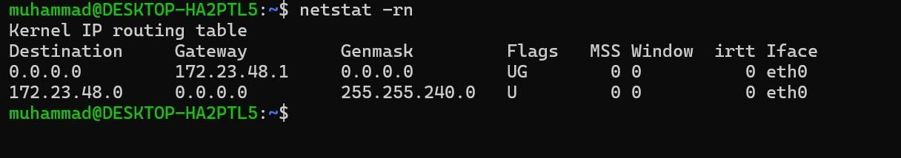

* Shows the routing table and network stats.

##### Set a Static IP (Simulation in WSL)

* + 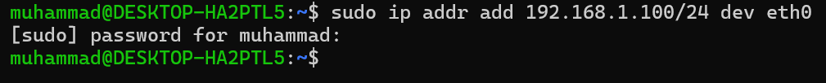Temporarily adds a static IP to interface eth0.
  + Verifies the new static IP is applied.

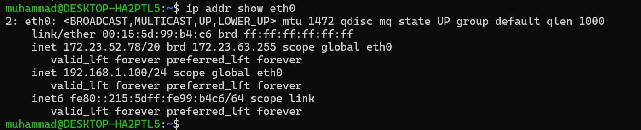

##### SSH Into Another System (if available)

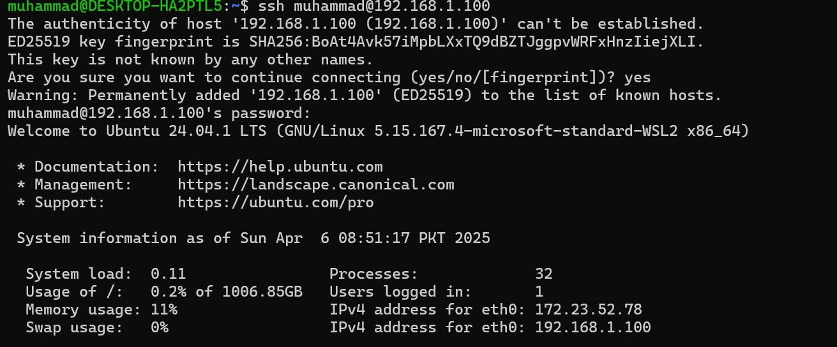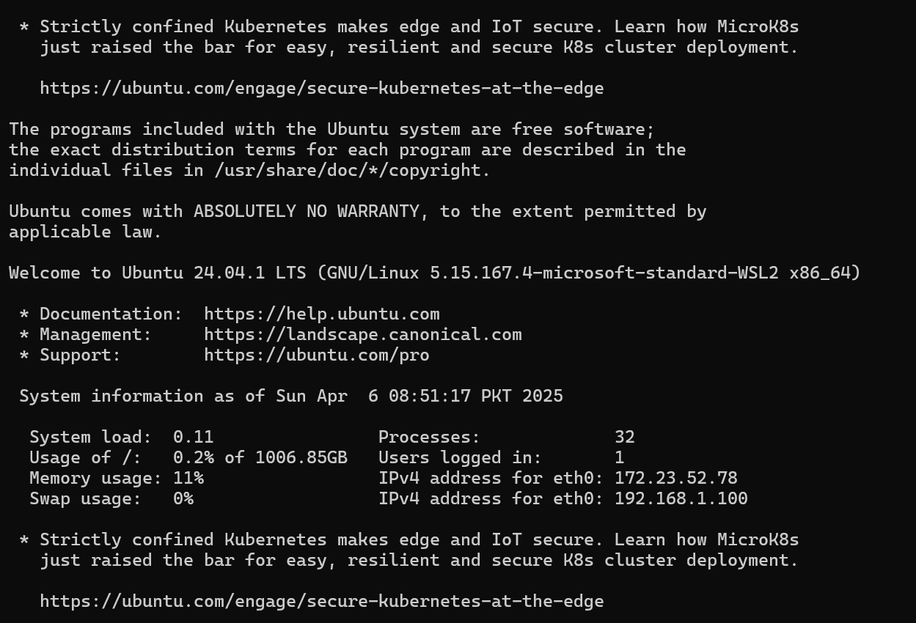

* Logs in to a remote machine using SSH.

##### Transfer File Using SCP

* Copies a file to another machine over SSH.

**GENERALIZED LAB RUBRICS**

|  |  |  |  |  |  |  |  |  |
| --- | --- | --- | --- | --- | --- | --- | --- | --- |
| **Domain** | **Component with Taxonomy** | **Above Expectatio n (4)** | **Meeting Expectatio n (3)** | **Approachin g Expectation**  **(2)** | **Below Expectatio n (1)** | **Used** | **Weight / 100**  **(Optional)** | **Scor e (1–**  **4)** |
| **Psychomotor** | **Building (**Hardware) | Is able to build a given setup neatly and timely using correct hardware components and / or can reorganize / adapt to new / special  requirements | Is able to assemble a given setup using correct hardware components after minor revisions | Is only able to copy a given setup using correct hardware components | Is not able to assemble a given setup using correct hardware components | ☐ |  |  |
| **Cognitive** | **Recording Measuremen ts** (Hardware  / Software) | Is able to record accurate measurements all the time | Is able to record accurate measurements most of the time | Is only able to record accurate measurements on some occasions | Is unable to record accurate measurements | ☐ |  |  |
| **Investigation**  (Software) | Is able to formulate  /develop theories in addition to evaluating  /concluding correctly about investigation parameters by assessing data | Is able to evaluate  /conclude correctly about investigation parameters by assessing data | Is partially able to evaluate  /conclude correctly about investigation parameters by assessing data | Is unable to comprehen d investigatio n  parameters | ☐ |  |  |
| **Design / Development of Solution** (Hardware / Software) | Is able to design / develop the solution of a given problem and add features to it | Is able to design / develop the solution of a given problem | Is able to partially design / develop the solution of a given problem | Is unable to partially design / develop the solution of a given problem | ☐ |  |  |
| **Software Usage** (Software) | Is adept in the use of software tool and can access advanced features | Is able to use the software tool effectively by accessing all the required  features | Is able to use the software tool but cannot access all the required features | Is unable to use the software tool | ☐ |  |  |
| **Programming Language** (Software) | Is able to efficiently complete a given task using advanced programming language constructs  / methods / commands and/or add features to the  original task | Is able to complete a given task using required programming language constructs / methods / commands | Is able to partially complete a given task | Is unable to partially complete a given task | ☐ |  |  |

**GENERALIZED LAB RUBRICS**

|  |  |  |  |  |  |  |  |  |
| --- | --- | --- | --- | --- | --- | --- | --- | --- |
| **Domain** | **Component with Taxonomy** | **Above Expectatio n (4)** | **Meeting**  **Expectati on (3)** | **Approachin g Expectation**  **(2)** | **Below Expectatio n (1)** | **Use d** | **Weight / 100**  **(Optional)** | **Scor e (1–**  **4)** |
| **Affective** | **Safety Instruction s (PLO6)** | Assesses and complies with all EHS instructions  while in lab | Assesses and complies with most EHS instructions while  in lab | Assesses and complies with some EHS instructions while in lab | Assesses and complies with few EHS instructions in lab | ☐ |  |  |
| **Profession al Ethics (PLO8)** | Exhibits exemplary professional ethics while writing lab reports and dealing with fellow students, lab staff and instructor all the time | Exhibits professional ethics while writing lab reports and dealing with fellow students, lab staff and instructor all the time | Makes an effort to exhibit professional ethics while writing lab reports and dealing with fellow students, lab staff and instructor all the time | Does not exhibit professional ethics while writing lab reports and dealing with fellow students, lab staff and instructor all the  time | ☐ |  |  |
| **Contributio n (PLO9)** | Consistently shows full preparation by completing all agreed tasks and provides additional resources for the group and work  quality is excellent | Consistently shows full preparation by completing all agreed tasks and work requires little or no revisions | Shows some preparation which is mostly at superficial level in completing a task and work requires much revisions and editing | Shows very little or no preparation in completing a task and work quality is poor | ☐ |  |  |
| **Attitude (PLO9)** | Internalized positive behavior and encourages and helps other  team members | Consistent positive behavior most of the time towards other  team members | Neither helpful nor damaging and shows disinterest in the performance of  others | Discouraging behavior towards other team members | ☐ |  |  |
| **Report Writing (PLO10)** | Report on all relevant sections related to the lab tasks is completed accurately, meeting the requirements, in prescribed time and with good language skills | Report on all relevant sections related to the lab tasks is completed but few deficiencies are present in terms of accuracy / meeting the requirements / prescribed time / good language  skills | Report on all relevant sections related to the lab tasks is completed but many deficiencies are present in terms of accuracy / meeting the requirements / prescribed time / good language  skills | Report on all relevant sections related to the lab tasks is not completed | ☐ |  |  |
| **Lab Task Manageme nt (PLO11)** | Manages tasks well within given timeframe | Manages tasks within given timeframe | Manages tasks in an extended timeframe | Does not manage tasks even in extended timeframes | ☐ |  |  |

##### Lab 11: Services and Daemons Objective: Manage system services. Topics:

* Starting and stopping services (`systemctl`, `service`).
* Understanding daemons.
* Managing system logs (`journalctl`).

##### Enable and disable services at boot

**Objective:**

Learn how to configure system services to start automatically at boot, or to disable them.

**Steps:**

* **Enable a service at boot:**

To enable a service so that it starts automatically at boot time, use the systemctl command. For example, to enable the **SSH service**:

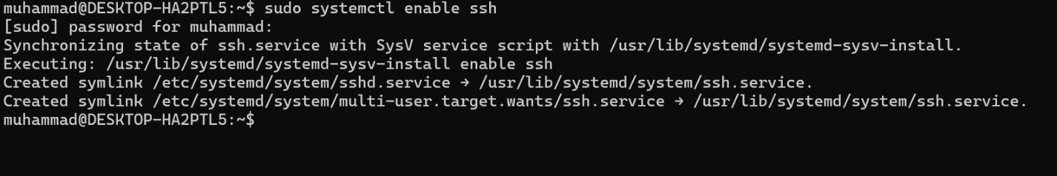

* This ensures the service will start automatically every time the system boots.
* **Disable a service at boot:**

To disable a service from starting at boot, use the following command:

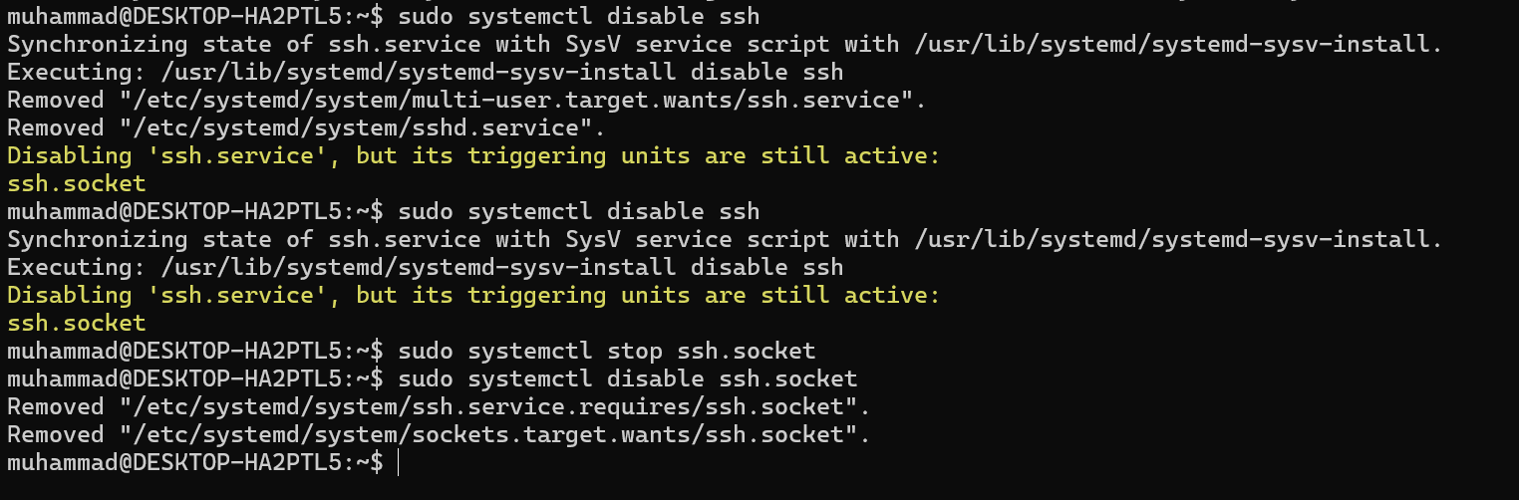

* This stops the SSH service from starting automatically at boot.

1. **Start and stop services manually**

To start and stop services manually using systemctl and service.

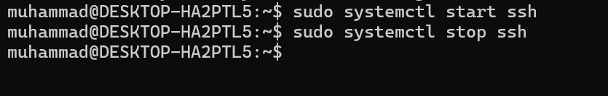

1. **Understanding Daemons**

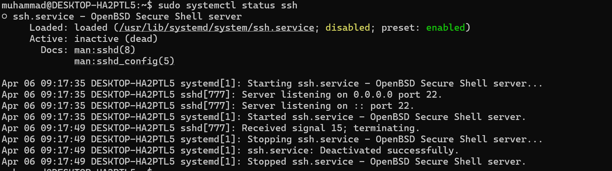

* Shows if the SSH service (daemon) is active, inactive, or failed.

1. **Monitor Logs for Specific Service**

* **View Logs for SSH:**

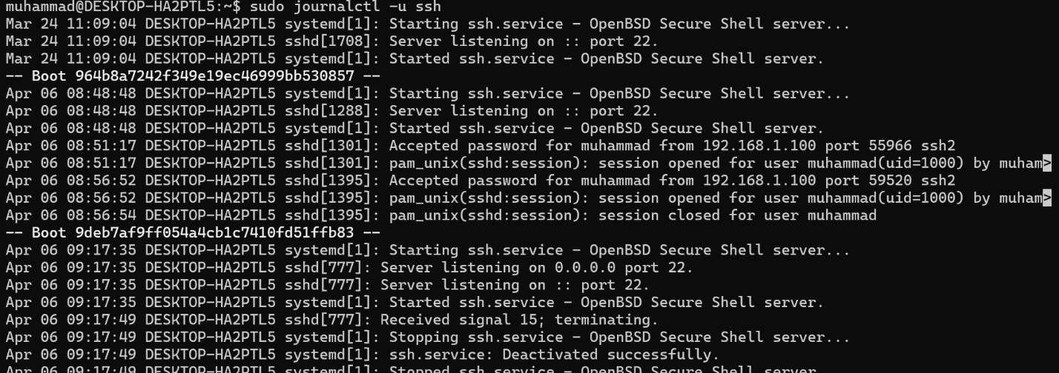

* Shows all SSH-related logs.
* **Live Monitor SSH Logs:**

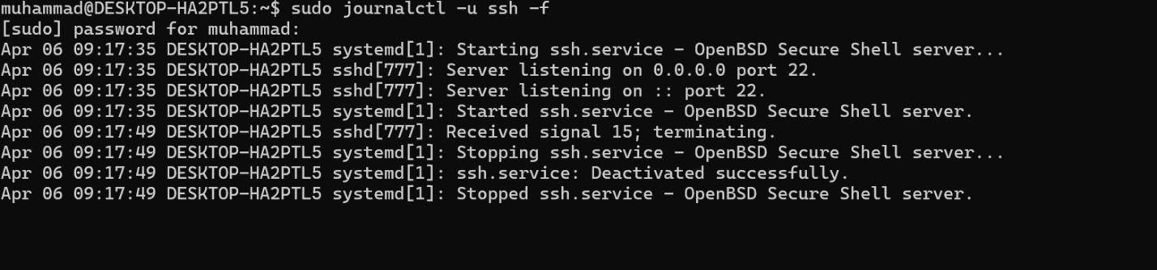

* Displays SSH logs in real-time.

1. **Review General System Logs**

* **View Entire System Log:**

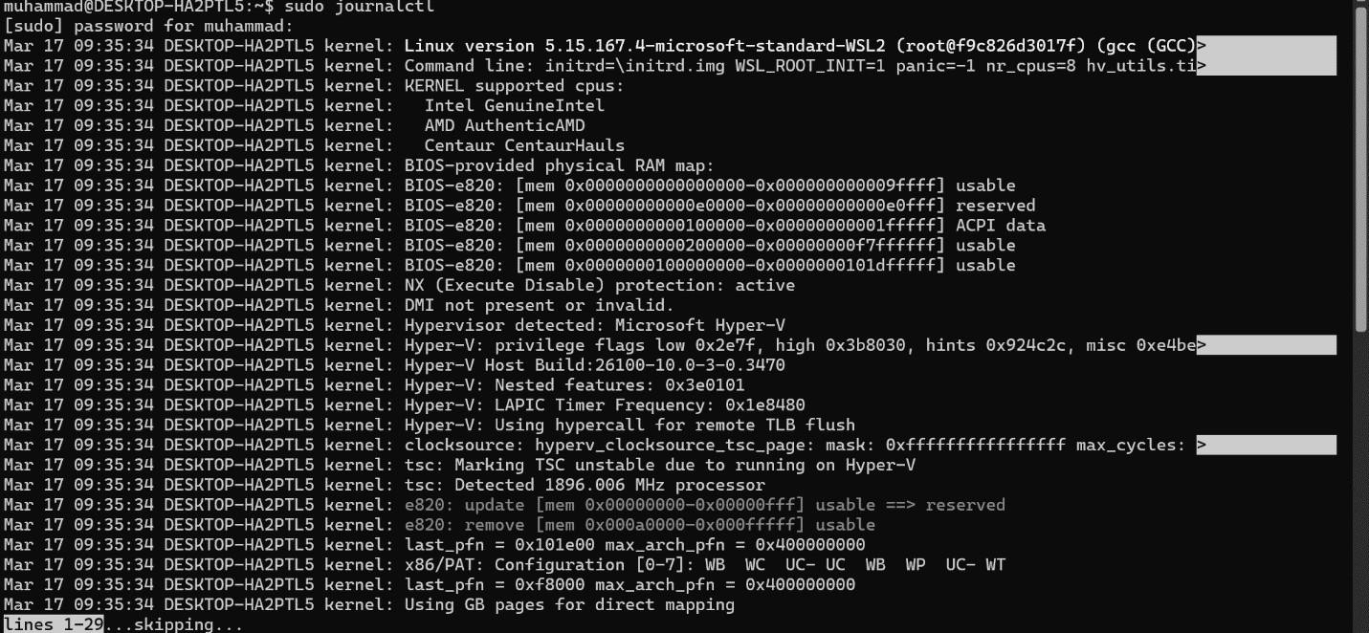

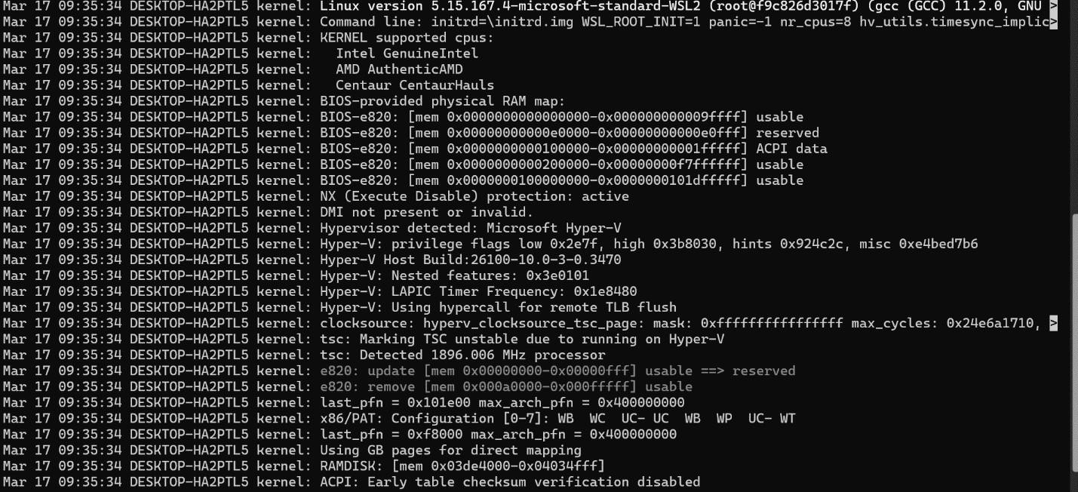

* **View Logs Since Last Boot:**

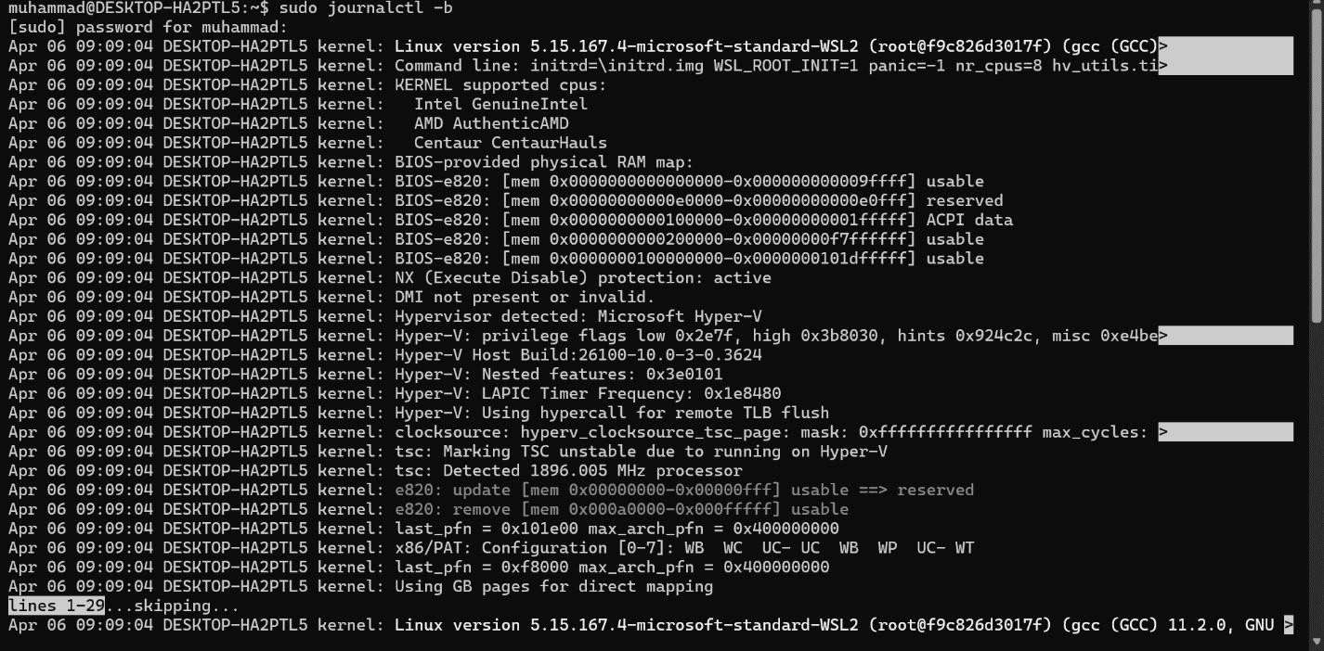

**GENERALIZED LAB RUBRICS**

|  |  |  |  |  |  |  |  |  |
| --- | --- | --- | --- | --- | --- | --- | --- | --- |
| **Domain** | **Component with Taxonomy** | **Above Expectatio n (4)** | **Meeting Expectatio n (3)** | **Approachin g Expectation**  **(2)** | **Below Expectatio n (1)** | **Used** | **Weight / 100**  **(Optional)** | **Scor e (1–**  **4)** |
| **Psychomotor** | **Building (**Hardware) | Is able to build a given setup neatly and timely using correct hardware components and / or can reorganize / adapt to new / special  requirements | Is able to assemble a given setup using correct hardware components after minor revisions | Is only able to copy a given setup using correct hardware components | Is not able to assemble a given setup using correct hardware components | ☐ |  |  |
| **Cognitive** | **Recording Measuremen ts** (Hardware  / Software) | Is able to record accurate measurements all the time | Is able to record accurate measurements most of the time | Is only able to record accurate measurements on some occasions | Is unable to record accurate measurements | ☐ |  |  |
| **Investigation**  (Software) | Is able to formulate  /develop theories in addition to evaluating  /concluding correctly about investigation parameters by assessing data | Is able to evaluate  /conclude correctly about investigation parameters by assessing data | Is partially able to evaluate  /conclude correctly about investigation parameters by assessing data | Is unable to comprehen d investigatio n  parameters | ☐ |  |  |
| **Design / Development of Solution** (Hardware / Software) | Is able to design / develop the solution of a given problem and add features to it | Is able to design / develop the solution of a given problem | Is able to partially design / develop the solution of a given problem | Is unable to partially design / develop the solution of a given problem | ☐ |  |  |
| **Software Usage** (Software) | Is adept in the use of software tool and can access advanced features | Is able to use the software tool effectively by accessing all the required  features | Is able to use the software tool but cannot access all the required features | Is unable to use the software tool | ☐ |  |  |
| **Programming Language** (Software) | Is able to efficiently complete a given task using advanced programming language constructs  / methods / commands and/or add features to the  original task | Is able to complete a given task using required programming language constructs / methods / commands | Is able to partially complete a given task | Is unable to partially complete a given task | ☐ |  |  |

**GENERALIZED LAB RUBRICS**

|  |  |  |  |  |  |  |  |  |
| --- | --- | --- | --- | --- | --- | --- | --- | --- |
| **Domain** | **Component with Taxonomy** | **Above Expectatio n (4)** | **Meeting**  **Expectati on (3)** | **Approachin g Expectation**  **(2)** | **Below Expectatio n (1)** | **Use d** | **Weight / 100**  **(Optional)** | **Scor e (1–**  **4)** |
| **Affective** | **Safety Instruction s (PLO6)** | Assesses and complies with all EHS instructions  while in lab | Assesses and complies with most EHS instructions while  in lab | Assesses and complies with some EHS instructions while in lab | Assesses and complies with few EHS instructions in lab | ☐ |  |  |
| **Profession al Ethics (PLO8)** | Exhibits exemplary professional ethics while writing lab reports and dealing with fellow students, lab staff and instructor all the time | Exhibits professional ethics while writing lab reports and dealing with fellow students, lab staff and instructor all the time | Makes an effort to exhibit professional ethics while writing lab reports and dealing with fellow students, lab staff and instructor all the time | Does not exhibit professional ethics while writing lab reports and dealing with fellow students, lab staff and instructor all the  time | ☐ |  |  |
| **Contributio n (PLO9)** | Consistently shows full preparation by completing all agreed tasks and provides additional resources for the group and work  quality is excellent | Consistently shows full preparation by completing all agreed tasks and work requires little or no revisions | Shows some preparation which is mostly at superficial level in completing a task and work requires much revisions and editing | Shows very little or no preparation in completing a task and work quality is poor | ☐ |  |  |
| **Attitude (PLO9)** | Internalized positive behavior and encourages and helps other  team members | Consistent positive behavior most of the time towards other  team members | Neither helpful nor damaging and shows disinterest in the performance of  others | Discouraging behavior towards other team members | ☐ |  |  |
| **Report Writing (PLO10)** | Report on all relevant sections related to the lab tasks is completed accurately, meeting the requirements, in prescribed time and with good language skills | Report on all relevant sections related to the lab tasks is completed but few deficiencies are present in terms of accuracy / meeting the requirements / prescribed time / good language  skills | Report on all relevant sections related to the lab tasks is completed but many deficiencies are present in terms of accuracy / meeting the requirements / prescribed time / good language  skills | Report on all relevant sections related to the lab tasks is not completed | ☐ |  |  |
| **Lab Task Manageme nt (PLO11)** | Manages tasks well within given timeframe | Manages tasks within given timeframe | Manages tasks in an extended timeframe | Does not manage tasks even in extended timeframes | ☐ |  |  |

Lab 12: Firewall and Security Objective: Learn basic Linux security. Topics:

* Using `iptables` and `ufw`.
* Securing SSH access.
* File encryption using `gpg`. Tasks:
* Block and allow specific ports using `ufw`.
* Set up SSH key-based authentication. Solution:

**Task 1: Configure Firewall using UFW Step 1: Enable UFW**



**Step 2: Check Firewall Status**

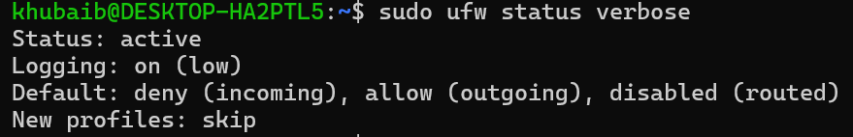

**Step 3: Allow Specific Port (e.g., SSH - Port 22)**

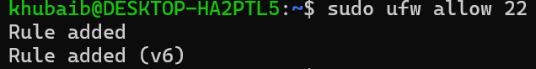

**Step 4: Block a Port (e.g., HTTP - Port 80)**

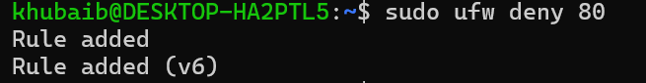

**Step 5: Delete a Rule (Optional)**

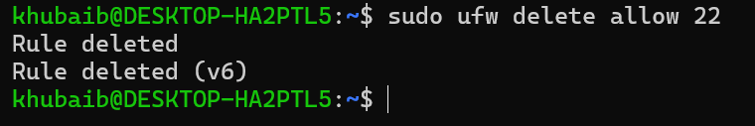

**Task 2: SSH Key-Based Authentication**

Note: SSH server might not run directly on WSL. You can still create keys and understand the configuration.

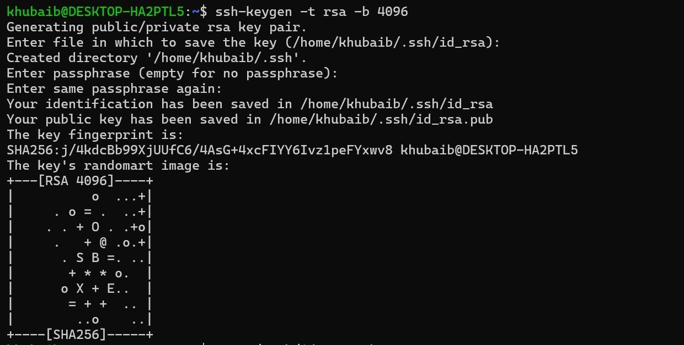**Step 1: Generate SSH Key Pair**

**Step 2: View the Public Key**

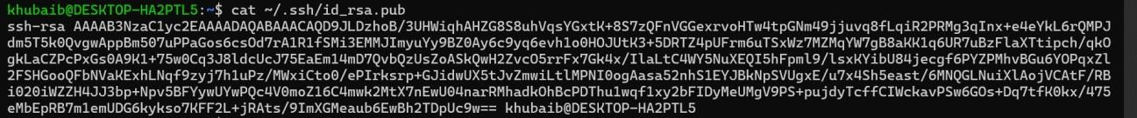

**Step 3: Copy the Public Key to Remote Server**

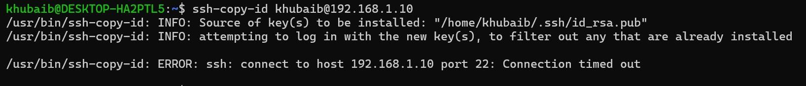**Step 4: Disable Password Authentication (on remote server)**

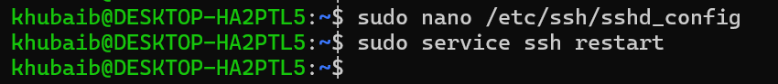

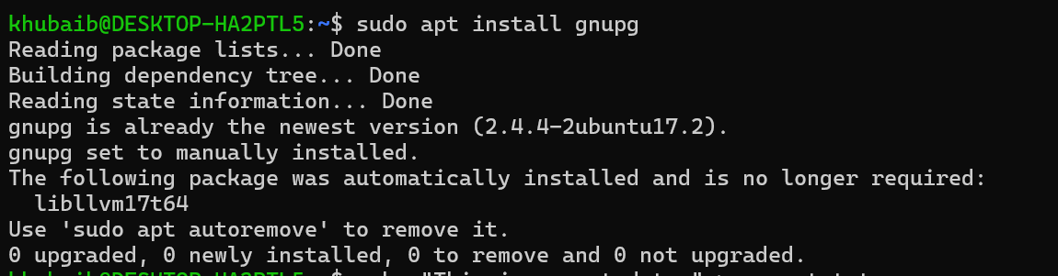**Task 3: Encrypt and Decrypt Files using GPG Step 1: Install GPG (if not installed)**

**Step 2: Create a File to Encrypt**



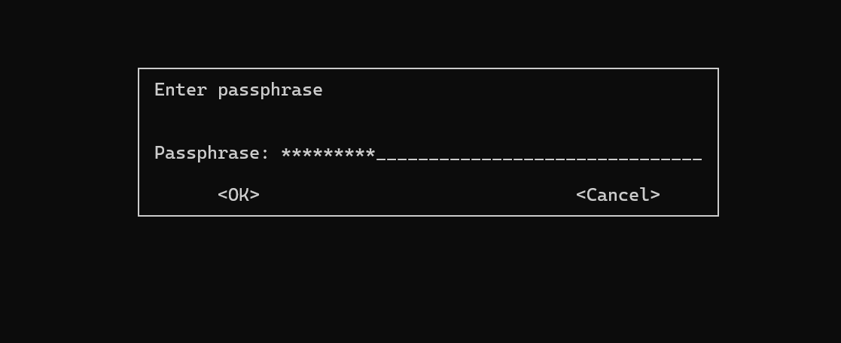**Step 3: Encrypt the File**

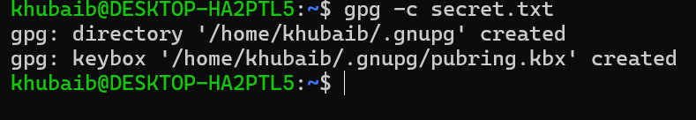

**Step 4: Decrypt the File**

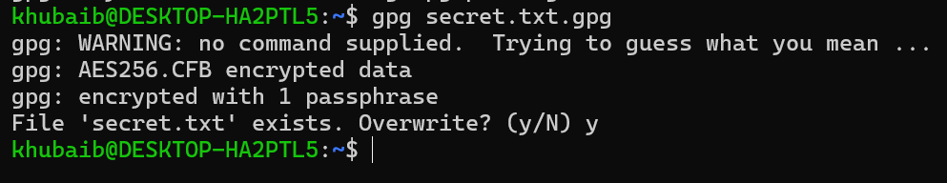

**GENERALIZED LAB RUBRICS**

|  |  |  |  |  |  |  |  |  |
| --- | --- | --- | --- | --- | --- | --- | --- | --- |
| **Domain** | **Component with Taxonomy** | **Above Expectatio n (4)** | **Meeting Expectatio n (3)** | **Approachin g Expectation**  **(2)** | **Below Expectatio n (1)** | **Used** | **Weight / 100**  **(Optional)** | **Scor e (1–**  **4)** |
| **Psychomotor** | **Building (**Hardware) | Is able to build a given setup neatly and timely using correct hardware components and / or can reorganize / adapt to new / special  requirements | Is able to assemble a given setup using correct hardware components after minor revisions | Is only able to copy a given setup using correct hardware components | Is not able to assemble a given setup using correct hardware components | ☐ |  |  |
| **Cognitive** | **Recording Measuremen ts** (Hardware  / Software) | Is able to record accurate measurements all the time | Is able to record accurate measurements most of the time | Is only able to record accurate measurements on some occasions | Is unable to record accurate measurements | ☐ |  |  |
| **Investigation**  (Software) | Is able to formulate  /develop theories in addition to evaluating  /concluding correctly about investigation parameters by assessing data | Is able to evaluate  /conclude correctly about investigation parameters by assessing data | Is partially able to evaluate  /conclude correctly about investigation parameters by assessing data | Is unable to comprehen d investigatio n  parameters | ☐ |  |  |
| **Design / Development of Solution** (Hardware / Software) | Is able to design / develop the solution of a given problem and add features to it | Is able to design / develop the solution of a given problem | Is able to partially design / develop the solution of a given problem | Is unable to partially design / develop the solution of a given problem | ☐ |  |  |
| **Software Usage** (Software) | Is adept in the use of software tool and can access advanced features | Is able to use the software tool effectively by accessing all the required  features | Is able to use the software tool but cannot access all the required features | Is unable to use the software tool | ☐ |  |  |
| **Programming Language** (Software) | Is able to efficiently complete a given task using advanced programming language constructs  / methods / commands and/or add features to the  original task | Is able to complete a given task using required programming language constructs / methods / commands | Is able to partially complete a given task | Is unable to partially complete a given task | ☐ |  |  |

**GENERALIZED LAB RUBRICS**

|  |  |  |  |  |  |  |  |  |
| --- | --- | --- | --- | --- | --- | --- | --- | --- |
| **Domain** | **Component with Taxonomy** | **Above Expectatio n (4)** | **Meeting**  **Expectati on (3)** | **Approachin g Expectation**  **(2)** | **Below Expectatio n (1)** | **Use d** | **Weight / 100**  **(Optional)** | **Scor e (1–**  **4)** |
| **Affective** | **Safety Instruction s (PLO6)** | Assesses and complies with all EHS instructions  while in lab | Assesses and complies with most EHS instructions while  in lab | Assesses and complies with some EHS instructions while in lab | Assesses and complies with few EHS instructions in lab | ☐ |  |  |
| **Profession al Ethics (PLO8)** | Exhibits exemplary professional ethics while writing lab reports and dealing with fellow students, lab staff and instructor all the time | Exhibits professional ethics while writing lab reports and dealing with fellow students, lab staff and instructor all the time | Makes an effort to exhibit professional ethics while writing lab reports and dealing with fellow students, lab staff and instructor all the time | Does not exhibit professional ethics while writing lab reports and dealing with fellow students, lab staff and instructor all the  time | ☐ |  |  |
| **Contributio n (PLO9)** | Consistently shows full preparation by completing all agreed tasks and provides additional resources for the group and work  quality is excellent | Consistently shows full preparation by completing all agreed tasks and work requires little or no revisions | Shows some preparation which is mostly at superficial level in completing a task and work requires much revisions and editing | Shows very little or no preparation in completing a task and work quality is poor | ☐ |  |  |
| **Attitude (PLO9)** | Internalized positive behavior and encourages and helps other  team members | Consistent positive behavior most of the time towards other  team members | Neither helpful nor damaging and shows disinterest in the performance of  others | Discouraging behavior towards other team members | ☐ |  |  |
| **Report Writing (PLO10)** | Report on all relevant sections related to the lab tasks is completed accurately, meeting the requirements, in prescribed time and with good language skills | Report on all relevant sections related to the lab tasks is completed but few deficiencies are present in terms of accuracy / meeting the requirements / prescribed time / good language  skills | Report on all relevant sections related to the lab tasks is completed but many deficiencies are present in terms of accuracy / meeting the requirements / prescribed time / good language  skills | Report on all relevant sections related to the lab tasks is not completed | ☐ |  |  |
| **Lab Task Manageme nt (PLO11)** | Manages tasks well within given timeframe | Manages tasks within given timeframe | Manages tasks in an extended timeframe | Does not manage tasks even in extended timeframes | ☐ |  |  |

# Lab 13: Virtualization with Linux

### Objective:

Set up and use virtualization tools.

### Topics:

* Installing and using VirtualBox or KVM.
* Creating virtual machines.
* Managing snapshots.

### Tasks:

* Install and configure a Linux VM.
* Test snapshots and rollbacks.

### Solution:

* + Well, I am using virtual Box for a while so in this I will tell the steps to install virtual box by Oracle by going to their official website: [https://www.virtualbox.org/wiki/Downloads.](https://www.virtualbox.org/wiki/Downloads)
  + an interface like this will pop up after installation:

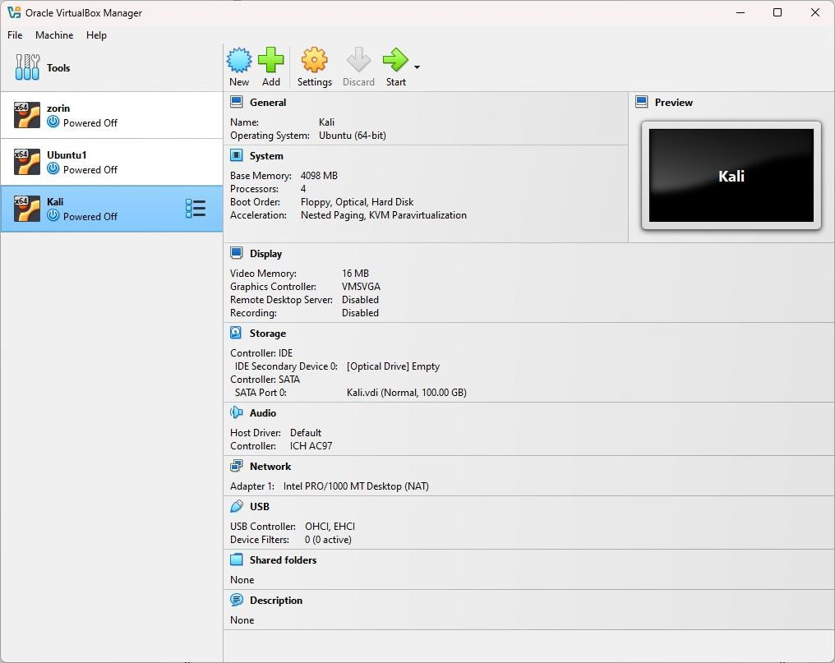

* + As I have told above, I have been using virtual box for a while that’s why you can see three different systems already integrated in the VM (Zorin, Ubuntu1, Kali).
  + we can add as many OS systems in VMs by clicking on the add or new button on top menu bar.
    1. We can use add option when we have disk image for the operating system.
    2. New is used to install operating system using iso file.

Now I am going to test snapshot and rollback.:

As you can see there is no snapshot currently, first let’s create a snapshot by clicking on ‘take’ in the top menu.

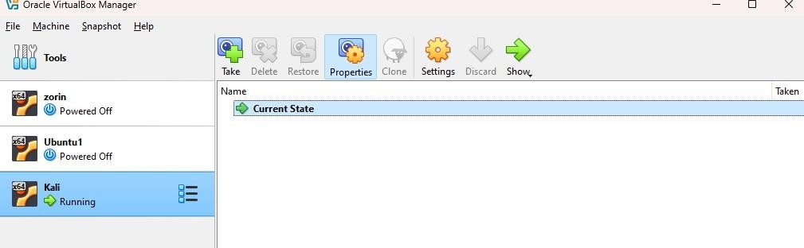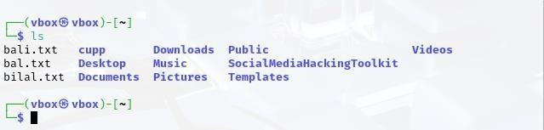

At the time of snapshot I have above files in my system.

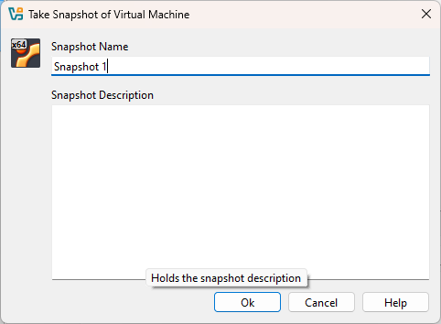

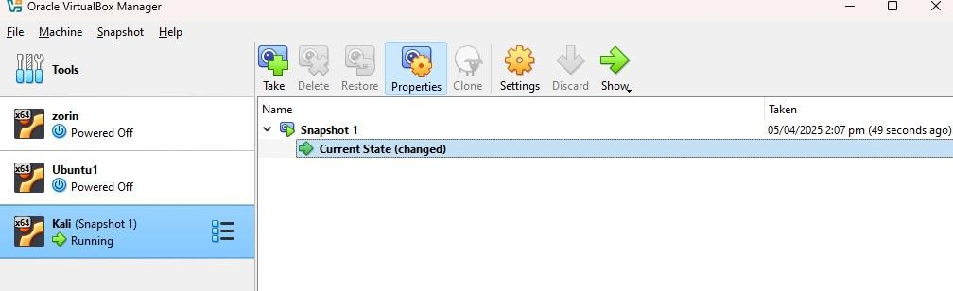

Now we have successfully created a snapshot let’s make some changes to test the rollback: I am going to create a txt file “test.txt” to make a change in the system after snapshot.

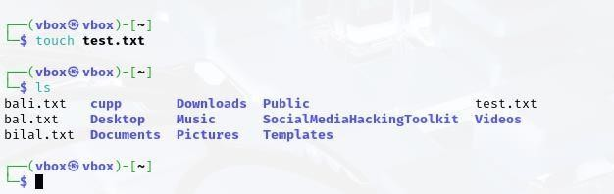

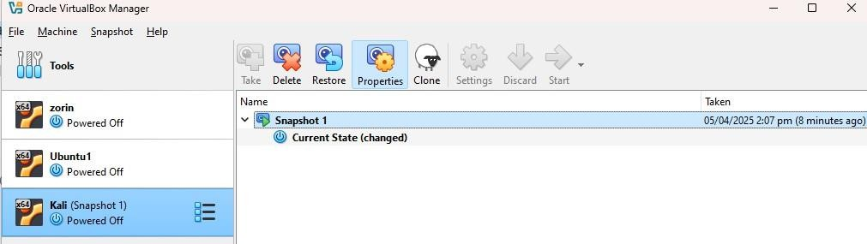

Now to do a rollback first power off the system and click on the snapshot that we have created before creating “test.txt” file.

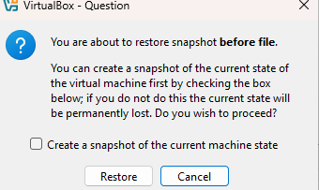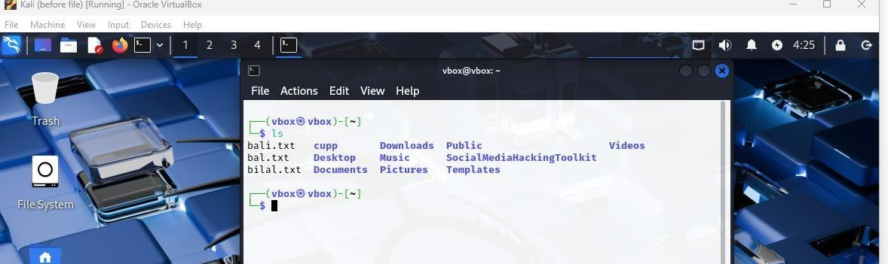

As you can see the system is rollback to the time before the “test.txt” was created.

**GENERALIZED LAB RUBRICS**

|  |  |  |  |  |  |  |  |  |
| --- | --- | --- | --- | --- | --- | --- | --- | --- |
| **Domain** | **Component with Taxonomy** | **Above Expectatio n (4)** | **Meeting Expectatio n (3)** | **Approachin g Expectation**  **(2)** | **Below Expectatio n (1)** | **Used** | **Weight / 100**  **(Optional)** | **Scor e (1–**  **4)** |
| **Psychomotor** | **Building (**Hardware) | Is able to build a given setup neatly and timely using correct hardware components and / or can reorganize / adapt to new / special  requirements | Is able to assemble a given setup using correct hardware components after minor revisions | Is only able to copy a given setup using correct hardware components | Is not able to assemble a given setup using correct hardware components | ☐ |  |  |
| **Cognitive** | **Recording Measuremen ts** (Hardware  / Software) | Is able to record accurate measurements all the time | Is able to record accurate measurements most of the time | Is only able to record accurate measurements on some occasions | Is unable to record accurate measurements | ☐ |  |  |
| **Investigation**  (Software) | Is able to formulate  /develop theories in addition to evaluating  /concluding correctly about investigation parameters by assessing data | Is able to evaluate  /conclude correctly about investigation parameters by assessing data | Is partially able to evaluate  /conclude correctly about investigation parameters by assessing data | Is unable to comprehen d investigatio n  parameters | ☐ |  |  |
| **Design / Development of Solution** (Hardware / Software) | Is able to design / develop the solution of a given problem and add features to it | Is able to design / develop the solution of a given problem | Is able to partially design / develop the solution of a given problem | Is unable to partially design / develop the solution of a given problem | ☐ |  |  |
| **Software Usage** (Software) | Is adept in the use of software tool and can access advanced features | Is able to use the software tool effectively by accessing all the required  features | Is able to use the software tool but cannot access all the required features | Is unable to use the software tool | ☐ |  |  |
| **Programming Language** (Software) | Is able to efficiently complete a given task using advanced programming language constructs  / methods / commands and/or add features to the  original task | Is able to complete a given task using required programming language constructs / methods / commands | Is able to partially complete a given task | Is unable to partially complete a given task | ☐ |  |  |

**GENERALIZED LAB RUBRICS**

|  |  |  |  |  |  |  |  |  |
| --- | --- | --- | --- | --- | --- | --- | --- | --- |
| **Domain** | **Component with Taxonomy** | **Above Expectatio n (4)** | **Meeting**  **Expectati on (3)** | **Approachin g Expectation**  **(2)** | **Below Expectatio n (1)** | **Use d** | **Weight / 100**  **(Optional)** | **Scor e (1–**  **4)** |
| **Affective** | **Safety Instruction s (PLO6)** | Assesses and complies with all EHS instructions  while in lab | Assesses and complies with most EHS instructions while  in lab | Assesses and complies with some EHS instructions while in lab | Assesses and complies with few EHS instructions in lab | ☐ |  |  |
| **Profession al Ethics (PLO8)** | Exhibits exemplary professional ethics while writing lab reports and dealing with fellow students, lab staff and instructor all the time | Exhibits professional ethics while writing lab reports and dealing with fellow students, lab staff and instructor all the time | Makes an effort to exhibit professional ethics while writing lab reports and dealing with fellow students, lab staff and instructor all the time | Does not exhibit professional ethics while writing lab reports and dealing with fellow students, lab staff and instructor all the  time | ☐ |  |  |
| **Contributio n (PLO9)** | Consistently shows full preparation by completing all agreed tasks and provides additional resources for the group and work  quality is excellent | Consistently shows full preparation by completing all agreed tasks and work requires little or no revisions | Shows some preparation which is mostly at superficial level in completing a task and work requires much revisions and editing | Shows very little or no preparation in completing a task and work quality is poor | ☐ |  |  |
| **Attitude (PLO9)** | Internalized positive behavior and encourages and helps other  team members | Consistent positive behavior most of the time towards other  team members | Neither helpful nor damaging and shows disinterest in the performance of  others | Discouraging behavior towards other team members | ☐ |  |  |
| **Report Writing (PLO10)** | Report on all relevant sections related to the lab tasks is completed accurately, meeting the requirements, in prescribed time and with good language skills | Report on all relevant sections related to the lab tasks is completed but few deficiencies are present in terms of accuracy / meeting the requirements / prescribed time / good language  skills | Report on all relevant sections related to the lab tasks is completed but many deficiencies are present in terms of accuracy / meeting the requirements / prescribed time / good language  skills | Report on all relevant sections related to the lab tasks is not completed | ☐ |  |  |
| **Lab Task Manageme nt (PLO11)** | Manages tasks well within given timeframe | Manages tasks within given timeframe | Manages tasks in an extended timeframe | Does not manage tasks even in extended timeframes | ☐ |  |  |

# Lab 14: Performance Monitoring

#### Objective:

Monitor system performance and troubleshoot

#### Topics:

* Using 'top', 'htop', 'iotop'.
* Monitoring disk I/O and memory usage.
* Checking logs for errors.

#### Tasks:

* Analyze system bottlenecks.
* Write a report on system performance.

#### Solution:

Checking system stats using top:

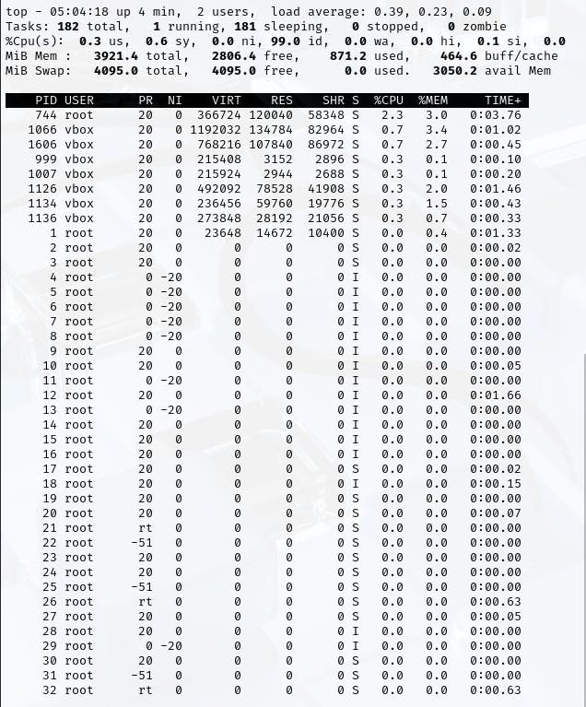

Checking system stats using htop:

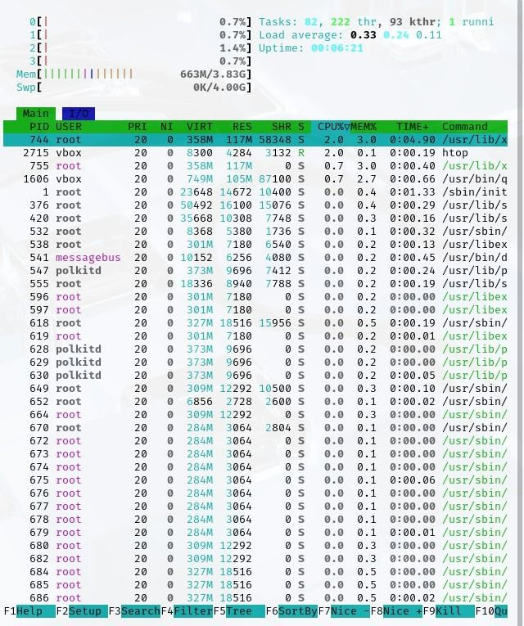

Checking system stats using iotop:

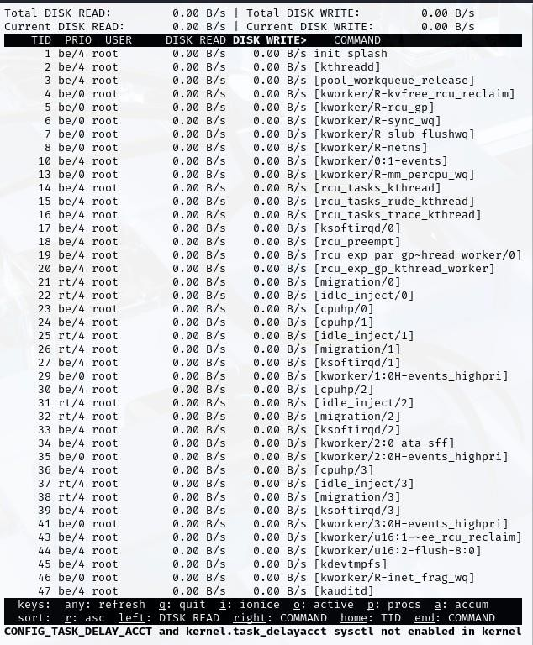

Checking system stats logs using systemctl for specific errors:

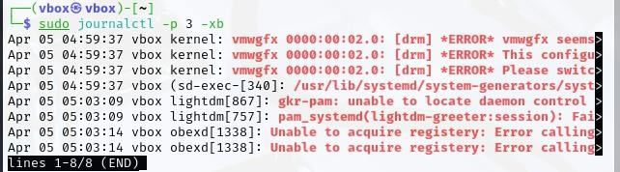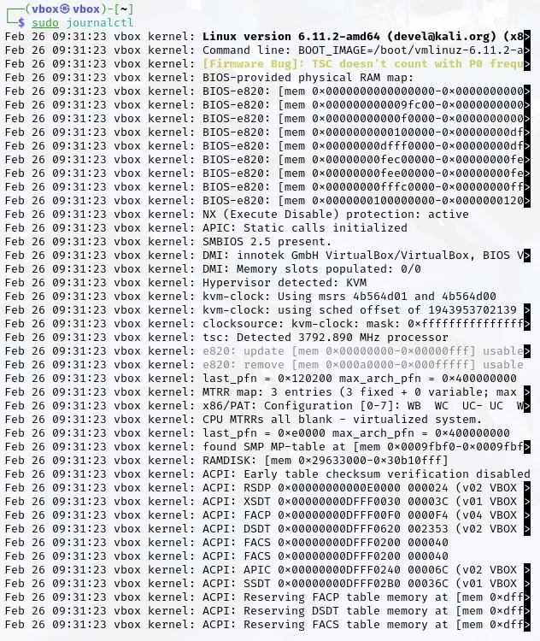

**SYSTEM PERFORMANCE MONITORING REPORT**

**Date:** April 5, 2025

**System:** Linux 6.11.2-amd64 (VirtualBox VM) **Analysis Period:** 05:04:18 - 05:03:14 **EXECUTIVE SUMMARY**

This report documents the performance analysis of a Linux system running in a VirtualBox virtualized environment. While the system demonstrates adequate resource

availability overall, several critical software errors have been identified that require attention. The detailed technical analysis provided herein offers insights into current system state and recommendations for performance optimization.

**SYSTEM SPECIFICATIONS**

|  |  |
| --- | --- |
| **Component** | **Details** |
| Operating System | Linux 6.11.2-amd64 [(devel@kali.org)](mailto:(devel@kali.org) |
| Virtualization | VirtualBox (innotek GmbH) |
| CPU | 3792.800 MHz processor |
| Memory | 3921.4 MB total RAM |
| Boot Parameters | BOOT_IMAGE=/boot/vmlinuz-6.11.2-amd64 |
| Uptime | 00:06:21 |
| Users | 2 |

**RESOURCE UTILIZATION METRICS**

**CPU Performance**

|  |  |  |  |  |  |
| --- | --- | --- | --- | --- | --- |
| **Metric** | | **Value** | **Technical Analysis** | |  |
| Load Average | | 0.33, 0.240, .11 | 1/5/15-minute averages indicate minimal system load with healthy  headroom | |
| Running Process es | | 1 of 182 ( 0 . 5 %) | Normal ratio; system not constrained by runnable processes | |
| CPU User Space | | 0.0%-2 . %3 | Minimal application CPU consumption | |
| CPU System Space | | 0.0%-0 . %7 | Kernel operations consuming minimal resources | |
| Process Priority | | Most processes at 20 | Standard scheduling priority with some processes at -20 (higher priority) | | |
|  |  |  |  |  | |
|  | |  |  | | |

Process 744 (root) consistently utilizes 2.0-2.3% CPU running /usr/lib/Xorg . The vbox user processes

(PIDs 715, 755, 1066, 1106) utilize between 0.3-0.7% CPU, indicating normal

graphics processing overhead for the virtual environment.

**Memory Allocation**

|  |  |  |  |  |
| --- | --- | --- | --- | --- |
| **Metric** | | **Value** | **Technical Analysis** | |
| Total Memory | | 3921.4 MB | Total physical RAM allocated to VM | |
| Free Memory | | 2806.4 MB (71.6%) | Substantial free memory available | |
| Used Memory | | 871.2 MB (22.2%) | Current application memory footprint | |
| Buffers/Cache | | 464.6 MB (11.8%) | Kernel file caching to improve I/O performance | |
| Total Swap | | 4095.0 MB | Virtual memory allocation | |
| Used Swap | | 0.0 MB (0%) | No swap usage indicates adequate physical memory | |
|  |  |  |  |  |

Memory allocation pattern shows healthy distribution with 663M/3.83G representation in htop output.

The memory-intensive processes include:

 PID 744: 358M VIRT, 117M RES (X server)

PID 1066: 1192M VIRT, 134M RES (vbox

process) PID 1106: 776M VIRT, 103M RES (vbox

process)

**Disk I/O Performance**

|  |  |  |
| --- | --- | --- |
| **Metric** | **Value** | **Technical Analysis** |
| Total Disk Read | 0.00 B/s | No current read operations |
| Total Disk Write | 0.00 B/s | No current write operations |
| Active Kernel I/O Threads | 47 | Multiple kernel I/O handlers active but idle |
| Disk Operation Types | kernel, rcu, migration, kworker | Standard kernel I/O management threads |

All disk I/O operations show 0.00 B/s for both read and write, indicating either system idle state or

[kworker/R-sync-wq]

efficient caching. Kernel threads such as[kworker/0:1-events] and

but not actively performing I/O operations.

are present

**ERROR ANALYSIS**

**Critical System Errors**



The vmgfx driver errors suggest hardware acceleration incompatibility between the virtual graphics adapter and the Linux driver. The "wedged" status indicates a driver lockup condition that may result in graphics performance degradation.

The system is running with KVM hypervisor detected within the VirtualBox environment, which suggests nested virtualization. This configuration can introduce additional performance overhead and may contribute to the graphics driver issues.

**GENERALIZED LAB RUBRICS**

|  |  |  |  |  |  |  |  |  |
| --- | --- | --- | --- | --- | --- | --- | --- | --- |
| **Domain** | **Component with Taxonomy** | **Above Expectatio n (4)** | **Meeting Expectatio n (3)** | **Approachin g Expectation**  **(2)** | **Below Expectatio n (1)** | **Used** | **Weight / 100**  **(Optional)** | **Scor e (1–**  **4)** |
| **Psychomotor** | **Building (**Hardware) | Is able to build a given setup neatly and timely using correct hardware components and / or can reorganize / adapt to new / special  requirements | Is able to assemble a given setup using correct hardware components after minor revisions | Is only able to copy a given setup using correct hardware components | Is not able to assemble a given setup using correct hardware components | ☐ |  |  |
| **Cognitive** | **Recording Measuremen ts** (Hardware  / Software) | Is able to record accurate measurements all the time | Is able to record accurate measurements most of the time | Is only able to record accurate measurements on some occasions | Is unable to record accurate measurements | ☐ |  |  |
| **Investigation**  (Software) | Is able to formulate  /develop theories in addition to evaluating  /concluding correctly about investigation parameters by assessing data | Is able to evaluate  /conclude correctly about investigation parameters by assessing data | Is partially able to evaluate  /conclude correctly about investigation parameters by assessing data | Is unable to comprehen d investigatio n  parameters | ☐ |  |  |
| **Design / Development of Solution** (Hardware / Software) | Is able to design / develop the solution of a given problem and add features to it | Is able to design / develop the solution of a given problem | Is able to partially design / develop the solution of a given problem | Is unable to partially design / develop the solution of a given problem | ☐ |  |  |
| **Software Usage** (Software) | Is adept in the use of software tool and can access advanced features | Is able to use the software tool effectively by accessing all the required  features | Is able to use the software tool but cannot access all the required features | Is unable to use the software tool | ☐ |  |  |
| **Programming Language** (Software) | Is able to efficiently complete a given task using advanced programming language constructs  / methods / commands and/or add features to the  original task | Is able to complete a given task using required programming language constructs / methods / commands | Is able to partially complete a given task | Is unable to partially complete a given task | ☐ |  |  |

**GENERALIZED LAB RUBRICS**

|  |  |  |  |  |  |  |  |  |
| --- | --- | --- | --- | --- | --- | --- | --- | --- |
| **Domain** | **Component with Taxonomy** | **Above Expectatio n (4)** | **Meeting**  **Expectati on (3)** | **Approachin g Expectation**  **(2)** | **Below Expectatio n (1)** | **Use d** | **Weight / 100**  **(Optional)** | **Scor e (1–**  **4)** |
| **Affective** | **Safety Instruction s (PLO6)** | Assesses and complies with all EHS instructions  while in lab | Assesses and complies with most EHS instructions while  in lab | Assesses and complies with some EHS instructions while in lab | Assesses and complies with few EHS instructions in lab | ☐ |  |  |
| **Profession al Ethics (PLO8)** | Exhibits exemplary professional ethics while writing lab reports and dealing with fellow students, lab staff and instructor all the time | Exhibits professional ethics while writing lab reports and dealing with fellow students, lab staff and instructor all the time | Makes an effort to exhibit professional ethics while writing lab reports and dealing with fellow students, lab staff and instructor all the time | Does not exhibit professional ethics while writing lab reports and dealing with fellow students, lab staff and instructor all the  time | ☐ |  |  |
| **Contributio n (PLO9)** | Consistently shows full preparation by completing all agreed tasks and provides additional resources for the group and work  quality is excellent | Consistently shows full preparation by completing all agreed tasks and work requires little or no revisions | Shows some preparation which is mostly at superficial level in completing a task and work requires much revisions and editing | Shows very little or no preparation in completing a task and work quality is poor | ☐ |  |  |
| **Attitude (PLO9)** | Internalized positive behavior and encourages and helps other  team members | Consistent positive behavior most of the time towards other  team members | Neither helpful nor damaging and shows disinterest in the performance of  others | Discouraging behavior towards other team members | ☐ |  |  |
| **Report Writing (PLO10)** | Report on all relevant sections related to the lab tasks is completed accurately, meeting the requirements, in prescribed time and with good language skills | Report on all relevant sections related to the lab tasks is completed but few deficiencies are present in terms of accuracy / meeting the requirements / prescribed time / good language  skills | Report on all relevant sections related to the lab tasks is completed but many deficiencies are present in terms of accuracy / meeting the requirements / prescribed time / good language  skills | Report on all relevant sections related to the lab tasks is not completed | ☐ |  |  |
| **Lab Task Manageme nt (PLO11)** | Manages tasks well within given timeframe | Manages tasks within given timeframe | Manages tasks in an extended timeframe | Does not manage tasks even in extended timeframes | ☐ |  |  |

## Lab 15: Final Project

**Objective:**

Combine all concepts into a real-world project.

**Tasks:**

* set up a complete LAMP (Linux, Apache, MySQL, PHI') server.
* Implement user permissions, firewall rules, and automation scripts.
* Document the setup and configurations.

**Solution:**

First I have setup the *apache2* server and run it to checked if it is working correctly:

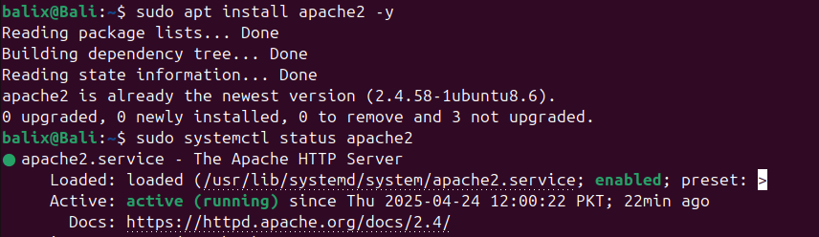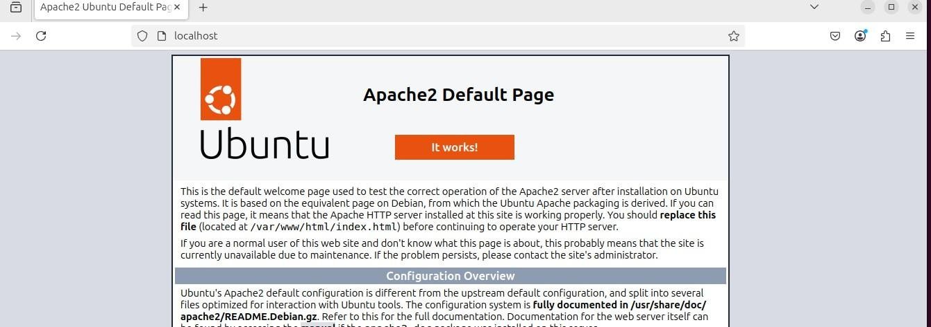

Now I will install the MySQL server in my linux:

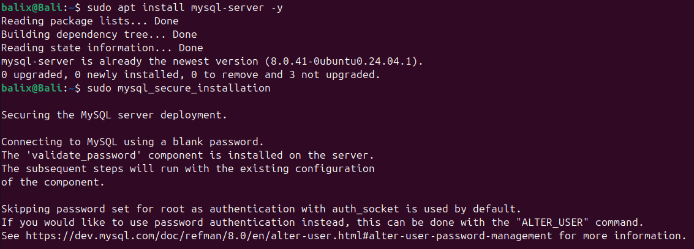

Now I will install PHP to run it on the server:

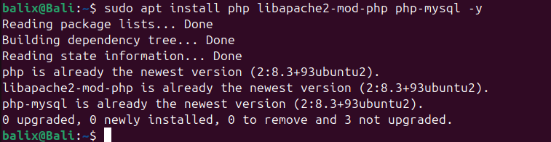

Let me test the php processing :



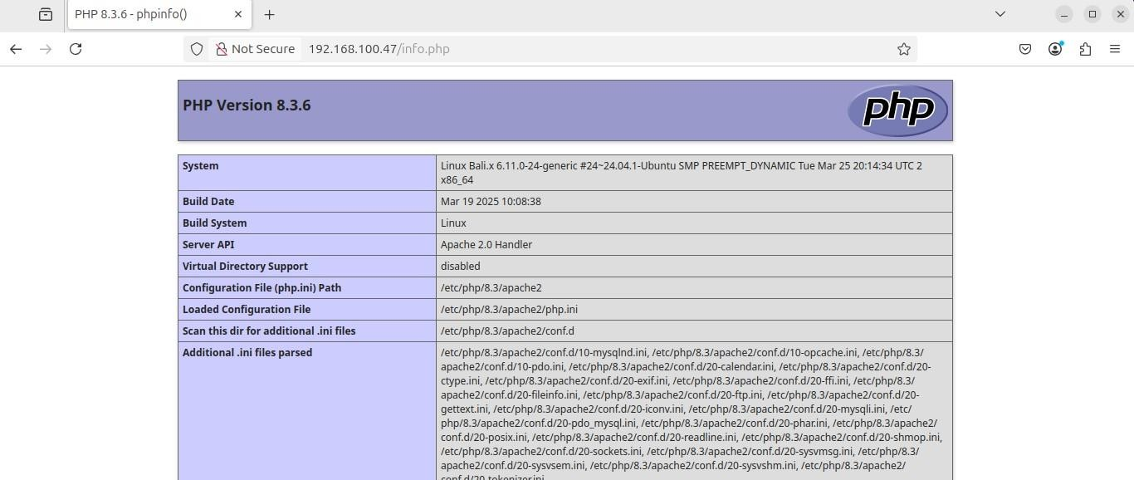

My php server has been setup successfully

Now I will create a new user in my Linux distro and grant it the permissions to asceses the LAMP stack server admirations

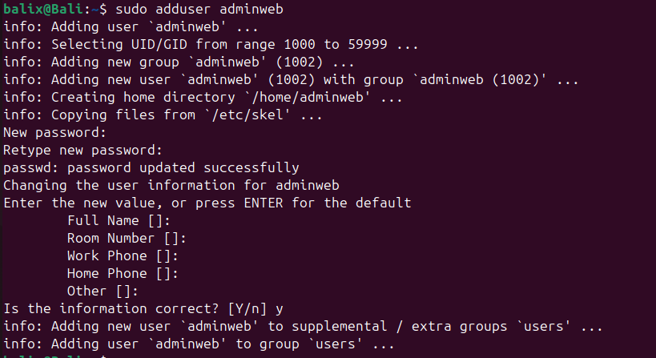

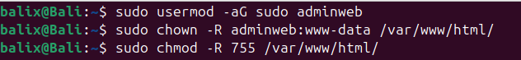

Now I will configure some firewall rules for my apache2 server:

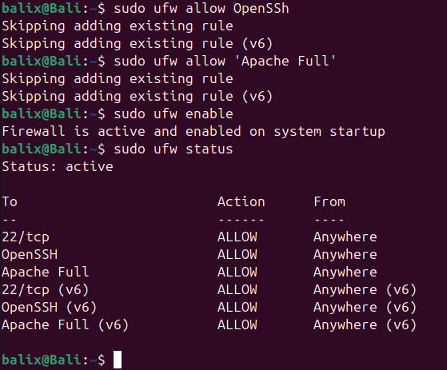

Now for the final step I will make the LAMP setup using a Bash script:

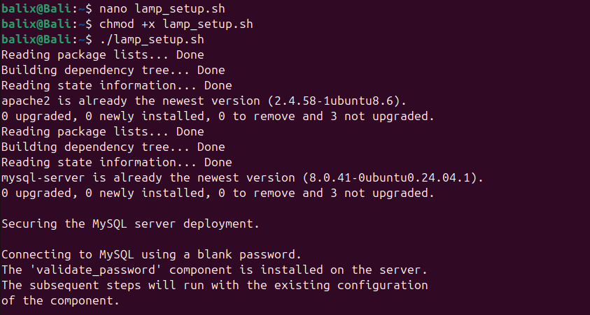

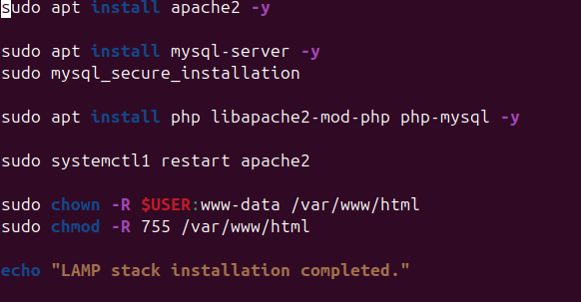

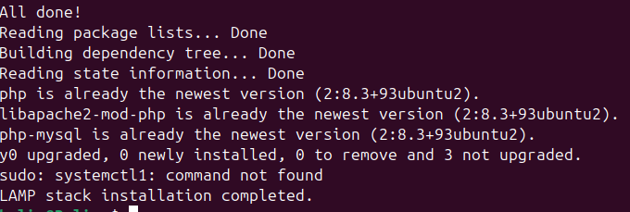

**GENERALIZED LAB RUBRICS**

|  |  |  |  |  |  |  |  |  |
| --- | --- | --- | --- | --- | --- | --- | --- | --- |
| **Domain** | **Component with Taxonomy** | **Above Expectatio n (4)** | **Meeting Expectatio n (3)** | **Approachin g Expectation**  **(2)** | **Below Expectatio n (1)** | **Used** | **Weight / 100**  **(Optional)** | **Scor e (1–**  **4)** |
| **Psychomotor** | **Building (**Hardware) | Is able to build a given setup neatly and timely using correct hardware components and / or can reorganize / adapt to new / special  requirements | Is able to assemble a given setup using correct hardware components after minor revisions | Is only able to copy a given setup using correct hardware components | Is not able to assemble a given setup using correct hardware components | ☐ |  |  |
| **Cognitive** | **Recording Measuremen ts** (Hardware  / Software) | Is able to record accurate measurements all the time | Is able to record accurate measurements most of the time | Is only able to record accurate measurements on some occasions | Is unable to record accurate measurements | ☐ |  |  |
| **Investigation**  (Software) | Is able to formulate  /develop theories in addition to evaluating  /concluding correctly about investigation parameters by assessing data | Is able to evaluate  /conclude correctly about investigation parameters by assessing data | Is partially able to evaluate  /conclude correctly about investigation parameters by assessing data | Is unable to comprehen d investigatio n  parameters | ☐ |  |  |
| **Design / Development of Solution** (Hardware / Software) | Is able to design / develop the solution of a given problem and add features to it | Is able to design / develop the solution of a given problem | Is able to partially design / develop the solution of a given problem | Is unable to partially design / develop the solution of a given problem | ☐ |  |  |
| **Software Usage** (Software) | Is adept in the use of software tool and can access advanced features | Is able to use the software tool effectively by accessing all the required  features | Is able to use the software tool but cannot access all the required features | Is unable to use the software tool | ☐ |  |  |
| **Programming Language** (Software) | Is able to efficiently complete a given task using advanced programming language constructs  / methods / commands and/or add features to the  original task | Is able to complete a given task using required programming language constructs / methods / commands | Is able to partially complete a given task | Is unable to partially complete a given task | ☐ |  |  |

**GENERALIZED LAB RUBRICS**

|  |  |  |  |  |  |  |  |  |
| --- | --- | --- | --- | --- | --- | --- | --- | --- |
| **Domain** | **Component with Taxonomy** | **Above Expectatio n (4)** | **Meeting**  **Expectati on (3)** | **Approachin g Expectation**  **(2)** | **Below Expectatio n (1)** | **Use d** | **Weight / 100**  **(Optional)** | **Scor e (1–**  **4)** |
| **Affective** | **Safety Instruction s (PLO6)** | Assesses and complies with all EHS instructions  while in lab | Assesses and complies with most EHS instructions while  in lab | Assesses and complies with some EHS instructions while in lab | Assesses and complies with few EHS instructions in lab | ☐ |  |  |
| **Profession al Ethics (PLO8)** | Exhibits exemplary professional ethics while writing lab reports and dealing with fellow students, lab staff and instructor all the time | Exhibits professional ethics while writing lab reports and dealing with fellow students, lab staff and instructor all the time | Makes an effort to exhibit professional ethics while writing lab reports and dealing with fellow students, lab staff and instructor all the time | Does not exhibit professional ethics while writing lab reports and dealing with fellow students, lab staff and instructor all the  time | ☐ |  |  |
| **Contributio n (PLO9)** | Consistently shows full preparation by completing all agreed tasks and provides additional resources for the group and work  quality is excellent | Consistently shows full preparation by completing all agreed tasks and work requires little or no revisions | Shows some preparation which is mostly at superficial level in completing a task and work requires much revisions and editing | Shows very little or no preparation in completing a task and work quality is poor | ☐ |  |  |
| **Attitude (PLO9)** | Internalized positive behavior and encourages and helps other  team members | Consistent positive behavior most of the time towards other  team members | Neither helpful nor damaging and shows disinterest in the performance of  others | Discouraging behavior towards other team members | ☐ |  |  |
| **Report Writing (PLO10)** | Report on all relevant sections related to the lab tasks is completed accurately, meeting the requirements, in prescribed time and with good language skills | Report on all relevant sections related to the lab tasks is completed but few deficiencies are present in terms of accuracy / meeting the requirements / prescribed time / good language  skills | Report on all relevant sections related to the lab tasks is completed but many deficiencies are present in terms of accuracy / meeting the requirements / prescribed time / good language  skills | Report on all relevant sections related to the lab tasks is not completed | ☐ |  |  |
| **Lab Task Manageme nt (PLO11)** | Manages tasks well within given timeframe | Manages tasks within given timeframe | Manages tasks in an extended timeframe | Does not manage tasks even in extended timeframes | ☐ |  |  |